DESIGN AND IMPLEMENTATION OF AN ESTATE VISITATION SYSTEM

Project Submitted in Partial Fulfillment of the Requirement

for the Award of

B.Sc.

In

Computer Science (Software Engineering)

By

Sadik Hassan Bello

BU/22C/IT/7888

To

The Department of Computer Science

Baze University, Abuja

SEPTEMBER, 2025

DESIGN AND IMPLEMENTATION OF AN ESTATE VISITATION SYSTEM

Project Submitted in Partial Fulfillment of the Requirement

for the Award of

B.Sc.

In

Computer Science (Software Engineering)

By

Sadik Hassan Bello

BU/22C/IT/7888

To

The Department of Computer Science

Baze University, Abuja

SEPTEMBER, 2025

**DECLARATION**

I, Sadik Hassan Bello, hereby declare that this Thesis title Design and Implementation of an Estate visitation System, which is submitted for partial fulfillment of the requirement for the award of B.sc. in Computer Science, majoring in Software Engineering to the department of Computer Science, Baze University Abuja, Nigeria, is my original work. All sources and contribution used have been duly acknowledged.

Date: Date Month Year Name of Student: Sadik Hassan Bello

**APPROVED BY** ……………………………

**HOD**

Department of Computer Science

**CERTIFICATION**

This is to certify that this Thesis titled Design and Implementation of an Estate Visitation System, which is submitted by Sadik Hassan Bello in partial fulfilment of the requirement for the award of degree for B.sc. in Software Engineering to the Department of computer Science, Baze University Abuja. The matter embodied in this thesis is original and has not been submitted for the award of any degree.

Date: Supervisor: Dr. Usman Abubakar

**APPROVAL**

This is to certify that the research work, Design and Implementation of an Estate Visitation system and the subsequent preparation by Sadik Hassan Bello with ID BU/22C/IT/7888 has been approved by the department of Computer Science, Faculty of Computing and Applied Science, Baze University, Abuja, Nigeria.

By

Dr. Usman Bello Abubakar Date

1st Supervisor

Dr. Usman Idris Abubakar Date

Head of Department

Prof Rufa’i Aliyu Date

Dean, Faculty of Computing and Applied Science

[Full name] Date

External Examiner

**DEDICATION**

Alhamdulillah, I express my gratitude to Almighty Allah for granting me the knowledge and wisdom required to successfully complete this project. It has indeed been a significant success. I extend my heartfelt thanks to my parents, Alhaji Hassan Bello and Hajiya Ubaida Hassan Bello, for their substantial contribution to the successful completion of this project. May Allah bless them and grant them Jannah. I am deeply thankful to Baze University for impacting valuable knowledge to me, I will forever be grateful for the impact it has had on my education. Special appreciation goes to my project supervisor Dr. Usman Abubakar, for his consistent educational support throughout the project. I also want to express my appreciation to my siblings, Maryam, Ameena, Abba, Muhammad, Mubarak, Abdul, Usman, Umar, Thank you for been there for my throughout my study sessions. I will like to thank my friends Muhammad Yakubu, Abdallah Muhammad, Abdulmalik Shinkafi, Baraka Abdullahi Laushi, Ahmad Sarki, Muhammad Namadina, Munira Musa, Fadimatou Musa, and many others for their unwavering support during my university journey. Your prayers have been truly appreciated.

**ABSTRACT**

The design and implementation of an estate visitor management system, created to enhance communication, security, and access control in residential estates, is presented in this project. Visitors can request entry and receive  QR passes, which security guards verify at the estate gate, as part of the system's organized guest access procedure. Through a dedicated dashboard, administrators can manage users, and keep an eye on estate activity, while residents enjoy features like service requests and bill payments. The solution increases estate security, improves accountability, and decreases manual operations by combining these features. All things considered, the project shows how technology can be utilized to make an estate environment that is safer, better organized, and easier to use.

Table of Contents

CHAPTER ONE 1

INTRODUCTION 1

1.1 Overview 1

1.2 Background and Motivation 1

1.3 Statement of the Problem 2

1.4 Aim and Objectives 2

1.5 Significance of the Project 3

1.6 Limitations of the Project 3

1.6 Project Risks Assessment 4

1.7 Scope/Project Organization 5

CHAPTER 2 6

LITERATURE REVIEW 6

2.1 Introduction 6

2.1.1 Global Innovations in Visitor Management 8

2.1.2 African and West African Contributions 9

2.1.3 Nigerian Context and Local Innovations 10

2.1.4 Privacy, Security, and Regulation 11

2.2 Historical Overview 11

2.3TheoreticalFramework 13

2.3.3 Socio Technical Systems Theory 14

2.6 Privacy, Security, and Regulation 15

2.7 Related Works 15

2.7.1 Gate Africa 15

2.7.2 VENCO Technologies 17

Table 2.2: Strengths and Weaknesses of VENCO 18

2.7.3 Sylogate Solutions 18

Table 2.3: Strengths and Weaknesses of Sylogate 20

2.7.4 Yardi Breeze 20

Table 2.4: Strengths and Weaknesses of Yardi Breeze 21

2.7.5 Rees Tech 22

Table 2.5: Strengths and Weaknesses of ReesTech 23

Table 2.6 Summary of the Related Works 24

2.8 Summary 25

CHAPTER 3 26

REQUIREMENTS ANALYSIS AND DESIGN 26

3.1 Overview 26

3.2 Proposed Model 26

3.3 Methodology 27

3.3.1 Method 1 (Interview) 27

3.3.2 Method 2 (Questionnaire) 27

3.4 Tools and Techniques 28

3.5 Ethical Consideration 28

3.7 Requirement Specifications 29

3.7.1 Functional Requirement Specifications 29

3.7.2 Non-Functional Requirement Specifications 30

Table 3.1 Non-Functional Requirement Specifications 30

3.8 System Design 31

An extensive overview of the key components that compose the Estate Visitation System is given in this section. They are as follows: 31

3.8.1 Application Architecture 32

3.8.2 Use Case 32

3.8.3 Data Design 35

Table 3.2 Data Dictionary for Visitor Table 35

Table 3.3 Data Dictionary for Resident Table 36

Table 3.4 Data Dictionary for Security Personnel Table 36

Table 3.5 Data Dictionary for Visitation Table 37

Table 3.6 Data Dictionary for Admin Table 37

3.8.4 Activity Diagrams 38

3.8.5 Control Flow Diagram 41

3.8.6 Entity Relationship Diagram (ERD) 42

3.8.6 User Interface Design 43

3.9 Summary 50

CHAPTER FOUR 51

IMPLEMENTATION AND TESTING 51

4.1Overview 51

4.2 Main Features 51

4.3 Implementation Problems 57

4.4 Resolving Issues with Implementation 57

4.5 Testing 58

4.5.1 Test Plans (For Unit Testing, Integration Testing, And System Testing) 58

4.5.2 Test Suite (For Unit Testing, Integration Testing And System Testing) 59

4.5.3 Test Traceability Matrix (For Unit Testing, Integration Testing And System Testing) 61

4.5.4 Test Report Summary (For Unit Testing, Integration Testing And System Testing) 61

4.5.5 Error Reports and Corrections 62

4.6 SUMMARY 62

CHAPTER FIVE: DISCUSSION, CONCLUSION, AND RECOMMENDATIONS 64

5.1 Overview 64

5.2 Objective Assessment 64

5.3 Limitations and Challenges 64

5.5 Future Work 65

5.4 Recommendations 65

5.6 Summary 66

References 67

APPENDIX A – Questionnaires 69

APPENDIX B – Use Guide 77

# LIST OF TABLES

Table 1.1: Risk Assessment ...........................................................................……...4

Table 2.1: Strengths and Weaknesses of Gate Africa…………………………......16

Table 2.2: Strengths and Weaknesses of Venco…………………………..............18

Table 2.3: Strengths and Weaknesses of Sylogate…………………………............20

Table 2.4: Strengths and Weaknesses of Yardi Breeeze……………………….…...21

Table 2.5: Strengths and Weaknesses of ReesTech………………………………...23

Table 2.6: Related works summary ...........................................................................24

Table 3.1: Functional requirements.......................................................................….29

Table 3.2: Non-Functional requirements ..............................................................…30

Table 3.3: Use-Case Description for Visitor Check in ..............................................33

Table 3.4: Use-Case Description for Resident ..........................................................34

Table 3.5: Use Case Description for Managing User’s Account...............................35

Table 3.6: Data Dictionary for visitor’s Table...........................................................35

Table 3.7: Data Dictionary for Resident’s Table .................................................….36

Table 3.8: Data Dictionary for Security Table..........................................................36

Table 3.9: Data Dictionary for Visitation Table....................................................37

Table 3.10: Data Dictionary for Admin Table......................................................37

Table 4.1: Test plan...............................................................................................58

Table 4.2: Test Suits ............................................................................................59

Table 4.3: Test Traceability Matrix......................................................................61

Table 4.4:Error Reports and Correction...............................................................60

# 

# LIST OF FIGURES

Figure 2.1: Gate Africa.....................................................................................................16

Figure 2.2: Gate Africa Homepage ..................................................................................16

Figure 2.3:Venco Technology Homepage..............................................……………….17

Figure 2.4: Venco Technology Homepage ....................................................…………..18

Figure 2.5: Sylogate Solution Homepage ....................................................................…19

Figure 2.6: Sylogate Solution Homepage.........................................................................19

Figure 2.7: Yardi Breeze Homepage................................................................................20

Figure 2.8: Yardi Breeze Homepage................................................................................21

Figure 2.9: ReesTech Homepage.....................................................................................22

Figure 2.10 ReesTech Homepage ................................................................……...……23

Figure 3.1: Agile Development .......................................................................................26

Figure 3.2: Application Architecture ...............................................................................32

Figure 3.3: Use case Diagram ..........................................................................................33

Figure 3.4: Visitation process Activity diagram ..............................................................38

Figure 3.5: Resident’s process Activity diagram.........................................................….39

Figure 3.6: Security process Activity diagram.................................................................40

Figure 3.7: Admin process Activity diagram...................................................................41

Figure 3.8: Control Flow Diagram...............................................................................…42

Figure 3.9: ERD Diagram ............................................………………………………....43

Figure 3.10: Visitor Log ..................................................................................................45

Figure 3.11: Tenants log .......................................................................………………...46

Figure 3.12: Bills Log ..................................................................................................…47

Figure 3.13: Admin Bills Log ...................................................................………….......48

Figure 3.14: Admin Household Log ................................................................………....48

Figure 3.15: Admin Alert Log .....................................................................................…49

Figure 3.16: Admin Visitor’s Log ...................................................................................49

Figure 3.17: Admin Report’s Log................................................................………..…..50

Figure 4.1:Admin Login page ....................................................................………..…...52

Figure 4.2 Resident Login page........................................................................………...53

Figure 4.3: Resident Dashboard ......................................................................................55

Figure 4.4: Admin Dashboard...............................................................................

# CHAPTER ONE

# INTRODUCTION

## Overview

Estate communities face growing challenges in managing residents, visitors, and security operations in a safe and efficient way. Traditional manual methods of recording visitor information, handling security alerts, and processing resident requests are often unreliable and time-consuming. With modern estates requiring stronger security and streamlined communication, there is a need for a digital solution that integrates residents, administrators, and security personnel into one platform.  
  
The Estate Management and Visitor Access System is designed to address these challenges. It provides a centralized platform for managing visitor access through QR codes, coordinating communication between residents, security, and administrators, and automating tasks such as bill payments, tenant management, and emergency alerts. The system consists of three user types: Admin (web application), Resident (mobile app), and Security (mobile app). Each user has defined privileges to ensure security, accountability, and smooth estate operations.

## 1.2 Background and Motivation

In many residential estates, visitor management and communication are still handled manually, often through physical logbooks, phone calls etc. These records are prone to errors, loss, or manipulation, which compromises estate security.In practice, visitor verification in Nigerian estates is often a lengthy and frustrating process. For example, in cities such as Abuja, Lagos, Kano, Kaduna, Katsina, Sokoto, and Bauchi, when a visitor arrives at the gate, the security personnel must first call the resident for confirmation. In some cases, the resident has to call back to reconfirm the details before the visitor is finally allowed entry. While this process is intended to improve safety, it is time-consuming, prone to miscommunication, and inconvenient for both residents and their guests.

Beyond visitor access, emergencies such as break-ins or maintenance issues are often communicated inefficiently, delaying response and putting residents at risk. Residents also lack structured systems for requesting handyman services or managing household subordinates, while administrators struggle to monitor estate-wide activities, keep track of tenants, and send timely announcements.

These gaps highlight the need for a secure and reliable system that automates routine processes while enhancing accountability. By introducing **QR code** verification, role-based access, and instant push notifications, this project seeks to make estate management more proactive, efficient, and transparent.

## 1.3 Statement of the Problem

The traditional methods of managing estates in Nigeria present several shortcomings. Visitor authentication is often unreliable, increasing the risk of unauthorized entry. Manual verification processes are slow, inconvenient, and prone to miscommunication. Emergency communication is frequently delayed, leaving estates vulnerable during critical situations. Furthermore, residents lack a structured platform for maintenance requests, while administrators struggle with poor record-keeping and manual operations that waste time, reduce efficiency, and lead to dissatisfaction. Without a digital system to integrate these processes, estate management remains prone to inefficiencies, risks, and miscommunication (Eze & Musa, 2021; Okoro, 2021).  
  
Without a digital system to integrate these processes, estate management remains prone to inefficiencies, risks, and miscommunication.

## 1.4 Aim and Objectives

The main aim of this research is to design and implement an Estate Management and Visitor Access System that enhances security, communication, and administrative efficiency in residential estates. This system will achieve the following:

* To develop a web-based dashboard for the admin to manage residents, security staff, and announcements.
* To build a mobile application for residents to create visitor invites, request handyman services, and send emergency alerts.
* To design a mobile application for security personnel to scan visitor QR codes and confirm entry.
* To implement QR code generation for secure visitor authentication.

## 1.5 Significance of the Project

The system will bring several benefits to estate communities:

* Enhanced Security: By replacing manual visitor logbooks with QR code verification, unauthorized entry is minimized.
* Efficient Communication: Residents, admins, and security staff can instantly exchange information through push notifications.
* Convenience for Residents: Tenants can request handyman services, manage subordinates, and receive updates from their mobile phones.
* Transparency for Administrators: Admins can monitor activities, track visitors, and ensure accountability of both residents and security staff.
* Better Record Keeping: All data on visitors, residents, and notifications are securely stored and can be retrieved when needed.
* Scalability: The system can be extended to support more features such as billing automation, community events, and biometric authentication in the future.

## 1.6 Limitations of the Project

* unable to obtain user GPS coordinates for more accurate tracking of visitor whereabouts.
* The resident-handyman service request module's picture upload feature is still underdeveloped.
* Residents and security personnel can view real-time updates on "Online" or "Offline" status indications.
* Instantaneous email alerts for visitation updates, bill production, and approvals.
* For improved login security, two-factor authentication (2FA) is not used.  
  automated check-in and check-out for guests without the need to manually scan barcodes or QR codes.

i

## 1.6 Project Risks Assessment

Table 1.1 Risk Assessment

|  |  |  |
| --- | --- | --- |
| RISK DESCRIPTION | MITIGATION | IMPACT |
| The technology might not be actively used by residents and security guards, which would result in poor acceptance and few advantages. | The system may become slower or experience performance problems as the number of users, guests, and records increases. | High |
| The system may become slower or experience performance problems as the number of users, guests, and records increases. | To manage massive volumes of data effectively, use indexing, pagination, and database design that are optimized. Think about hosting options that are scalable. | High |
| Building all features (such as a maintenance module, emergency alarms, and analytics) prior to launch may not be possible due to the project timetable. | Prioritize creating a Minimum Viable Product (MVP) with essential functionality before adding more advanced features in subsequent iterations. | Medium |
| Inappropriate or misleading information (such as fake names or maintenance requests) may be uploaded or shared by visitors or residents. | Establish an admin panel to examine any data that has been submitted, and implement a reporting/flagged mechanism to identify and stop questionable activities. | High |
| It could be challenging to verify guests and residents, particularly in big estates. | Requires identity for visitors access to check in and confirm authenticity. | High |

## 1.7 Scope/Project Organization

The scope of this project covers the design and implementation of an estate management system with three primary user roles:  
  
- Admin (Web): Login, manage residents/security, send announcements, manage handyman services, and view system data.  
- Resident (Mobile): Login, create/manage invites, manage subordinates (up to 4), request handyman services, and send emergency alerts.  
- Security (Mobile): Login, change password, scan visitor QR code, and confirm guest entry.  
  
The system will also include QR code generation, push notification integration, and visitor log management.

# CHAPTER 2

# LITERATURE REVIEW

## 2.1 Introduction

## In many housing estates, visitor records are still kept the old-fashioned way using paper logbooks, phone calls, or handwritten notes, some don't even record it which puts a question mark on the security of the residents. Even though this is common, it is very slow, and mistakes can be easily made, and not very secure since records can be lost or tampered with. For example, in cities like Abuja, Lagos, Kano, Sokoto, Port Harcourt, etc. visitors mostly wait at the gate while security tries to call the residents to confirm their identity. Sometimes, calls go unanswered, either phones switched off, numbers are dialed incorrectly, or residents respond late. These small delays often cause unnecessary stress for visitors, who may feel unwelcome, and for residents, who may be interrupted or inconvenienced.

## Apart from managing the entry of visitors, most estates also struggle when it comes to handling emergencies. Situations like burglary attempts, fire outbreaks, or medical issues are mostly reported through casual means like phone calls,, or rushing to the gate. Because of this, responses are usually delayed, and residents can be left exposed to greater risks.

## Beyond emergencies, day-to-day needs within estates are also poorly organized. in most cases the residents don’t have a proper system to request handyman services, track payments, or monitor tenants. For administrators, it’s also challenging because they may find it difficult to send out urgent announcements, keep accurate records, or coordinate estate affairs smoothly.

## These gaps may seem like small inconveniences at first, but over time they add up. They affect safety, make estate living less comfortable, and leave communities more vulnerable to both security threats and avoidable misunderstandings.

## In the world we are in now cities are still growing and residential communities keep expanding, the weaknesses of manual systems are becoming harder to ignore. With more people moving into estates, this automatically means more visitors, more delivery drivers, and more service providers showing up at the gates day by day. Traditional methods like the normal phone calls will be very difficult to keep up with this growing demand.

## Paper logbooks, for example, often turn out to be useless when needed most because handwriting may be difficult to read, important details might be skipped, or records could even go missing entirely. Relying on phone calls also has its limits, especially in areas where mobile networks are weak or residents cannot pick up immediately or maybe even phones are switched off. What used to feel manageable in smaller communities has now grown into a system that is stretched thin, frustrating for everyone, and no longer reliable.

## This growing challenge is the reason why many estates are now turning to digital solutions for their daily operations. Around the world, both residential estates and commercial buildings have been moving away from handwritten registers and adopting smarter technologies, often driven by global events and advances in innovation to make everything easier.

## Research shows that during the COVID-19 pandemic (2020–2021), the need to limit physical contact pushed many communities to adopt touchless systems such as QR codes and mobile passes for visitor verification (Gopinath & Chen, 2021). Not long after, from 2021 onward, cloud-based platforms and SaaS solutions introduced features like instant mobile notifications, integration with CCTV cameras, and centralized dashboards that gave administrators a real-time view of what was happening across their estates (Helixbeat Research, 2022). By 2023, the shift had gone even further, with artificial intelligence tools—like facial recognition and license plate detection—being used to verify access more quickly and accurately than humans ever could (Olaniyi & Adnan, 2023; Wei & Sun, 2024).

#### Africa is not being left behind in this time of digital transformation. In Nigeria, PropTech firms like VENCO and Gate Africa are already showing how global innovations can be adapted to solve local problems in practical ways. For example, Gate Africa, which is an app that allows residents to generate secure invitation codes for their guests whether it’s a one-time visit, a multi-day stay, or even a large family event. Instead of visitors waiting for a very long time at the gate while security makes phone calls, they can just simply present the code at the gate, and access is granted within seconds. The platform also includes estate payments, emergency alerts, and a community marketplace for services like technicians and handymen (The Guardian Nigeria, 2024). In addition, all visitor entries are logged in the cloud, and residents receive real-time notifications that improve both convenience and security (The Nation, 2024).

#### On the other hand, VENCO has focused on building an all-in-one platform for estate operations. It goes beyond visitor access to cover service charge payments, utility vending, and tenant communication. In 2025, BusinessDay reported that VENCO secured regulatory approval to deploy smart meters across Nigeria, helping communities track electricity usage and bill residents more transparently (BusinessDay, 2025). Earlier, Nairametrics noted that VENCO raised $670,000 which is approximately ₦1,029,448,300 in Nigerian currency in pre-seed funding to expand a platform that handles collections, utilities vending, visitor logs, and incident reporting in estates (Nairametrics, 2022).

### 2.1.1 Global Innovations in Visitor Management

Researchers have explored how blockchain and smart contracts can provide decentralized access control for smart buildings. For example, Bindra et al. (2020) demonstrated how blockchain could be used to grant both long-term occupants and short-term visitors tamper-resistant access privileges, reducing administrative overhead while ensuring transparency. Similarly, Stock (2022) developed a blockchain-based visitor authentication system using IoT devices and smart contracts, showing how these type of solutions can create secure and auditable visitor logs. Although, both studies shows that successful deployment depends on reliable computational infrastructure and internet access factors that can limit feasibility in many developing regions (Bindra et al., 2020; Stock, 2022).

During the COVID-19 pandemic, QR-code systems became a widely adopted solution for touchless visitor verification. In Singapore, for example, the SafeEntry system allowed visitors to scan QR codes to record their entry and exit at public and private facilities, which allows efficient contact tracing while minimizing physical contact (SafeEntry, n.d.). Industry analysts have also described QR codes as a “digital access revolution,” since they can be quickly issued to visitors and integrated into existing gate security systems (Sentry Interactive, n.d.). While it is effective in contexts with stable internet connectivity and high digital literacy, these systems are less accessible for populations with limited smartphone use or poor network coverage.

Another innovation is the use of artificial intelligence for vehicle-based access control. Modern deep learning models like YOLOv8 have achieved high accuracy in detecting and recognizing license plates in real time, making them useful for automating gate entry and reducing manual checks (Savant-AI, 2023; Ultralytics, 2024). Recent experiments even show optimized YOLOv8 models running effectively on resource-constrained hardware, making them more practical for real-world applications (Satya, 2025). Although, these systems still depend so much on high-quality cameras, steady electricity, and very reliable networks which are factors that can remain a challenge in Nigerian estates.

### 2.1.2 African and West African Contributions

Across Africa, PropTech adoption is steadily growing. Mensah and Boateng (2024) studied mobile-first PropTech systems in West Africa. They found that smartphones remain the most practical medium for digital visitor management, as they combine affordability with accessibility. However, their study also revealed persistent challenges such as poor internet coverage, residents reluctance to adopt new technology, and security guards limited training.

In South Africa, platforms such as EstateMate and EasyRoster have been adopted, offering resident-controlled approvals, tenant communication, and roster management for staff. In Kenya, Digital Gates uses SMS based verification codes, catering to residents in estates with limited smartphone access. These demonstrate Africa’s emphasis on affordability, adaptability, and simplicity in technology adoptionIbrahim and Musa (2023) analyzed barriers to PropTech adoption in Nigeria. They identified three main challenges: high initial costs, trust deficits between service providers and residents, and inconsistent regulatory support from government institutions. Their findings highlight why many estates continue to rely on manual visitor logs despite acknowledging their inefficiency.

Daramola and Usman (2024) investigated user experiences in Lagos estates where digital visitor systems had been deployed. Their study found that residents were often frustrated with system downtime, poor interface design, and the lack of integration with other estate services such as handyman booking or emergency alerts. This illustrates that usability is as important as functionality in driving adoption.

### 2.1.3 Nigerian Context and Local Innovations

In Nigeria, PropTech companies are beginning to adapt visitor management solutions to fit local realities. A leading example is VENCO Technologies, which offers an integrated platform that combines visitor management, billing, utilities vending, and issue reporting for residential estates. However, industry reports note that adoption has mostly been limited to premium estates because of a very high subscription costs (TechEconomy, 2025).

Also, Gate Africa, which is a platform that allows residents to generate digital visitor codes either one-time, multi-day, or event-based which security personnel scan at the gate. This system reduces delays and improves accountability, and at the same time also integrating features like payments, community forums, and emergency alerts (Vanguard, 2024; The Nation, 2024).

Sylogate is also contributing to this space with a platform that focuses on affordability and functionality. It provides QR-code visitor passes, resident directories, and real-time dashboards for estate managers. By focusing on simplicity, Sylogate aims to serve both middle-income and luxury estates (Sylogate, 2024).

These platforms are examples which shows that local PropTech solutions are moving beyond paper registers and unreliable phone calls. Although, challenges remain especially around affordability, resident adoption, and training for security staff. This means that while Nigeria is catching up with global PropTech trends, solutions still need to be related carefully to the needs of the community rather than imported wholesale.

### 2.1.4 Privacy, Security, and Regulation

Privacy is not just a tech term, it is something that matters deeply in our communities. In Nigeria, a strong data protection law called the Nigeria Data Protection Act (NDPA) was signed into law to protect people's personal information. NDPA, The body responsible for ensuring compliance (DLA Piper, 2025). The NDPA sets clear rules about how businesses should collect and use personal data. For instance, companies must explain why they collect data, who will see it, how long it will be stored, and have someone in charge of protecting it (DLA Piper, 2025; DataGuidance, 2025). The NDPC recently fined a bank for processing customer data without meaningful consent which is a real-life case demonstrating that the law has teeth (Reuters, 2024).

## 2.2 Historical Overview

In the early days, estates and commercial buildings didn't even track visitors. But as time passed by, estates and commercial buildings tracked visitors using paper logbooks. Security guards would manually record names, phone numbers, and times of entry simple and affordable, but not dependable. Records were often messy, illegible, or lost (Certify.me, 2025; Wikipedia, 2025).

When digital tools were not yet available, guards relied on phone calls confirm visitors with residents. If the resident didn’t answer, guards had to make judgment calls, which risked security. This was especially problematic in areas with unstable electricity or poor network coverage, such as some parts of Nigeria.

By the early 2000s, wealthier estates and properties in developed countries began using electronic visitor logs or spreadsheet systems. This was a step forward but in regions like Nigeria, the high cost of computers, spotty power supply, and lack of technical skills often sent operations back to paper.

In the mid-2000s to early 2010s, estates began adopting access methods like smart cards, RFID badges, and biometric scanners. These systems offered tighter control and convenience, especially in high-security zones like luxury estates and airports. Although, they were expensive and sometimes slow leading to bottlenecks at entry points (NexGenSensors, 2025; Oloid, 2023).

The COVID-19 pandemic prompted a rapid shift towards contactless systems. QR codes and mobile passes became popular as they avoided shared surfaces and sped up entry (Certify.me, 2025). Guards could simply scan a code rather than exchange pens or touch visitor IDs making check-in safer and more efficient.

Once cloud computing matured, visitor management systems began operating as software-as-a-service (SaaS). Properties gained centralized dashboards to manage access control across multiple gates, receive alerts, and incorporate CCTV or mobile notifications all in real time (BusinessBod, 2025; MyBOS, 2024). However, these systems also highlighted a digital divide where regions with unstable internet or power struggled to reap full benefits.

Artificial intelligence changed the game again. Facial recognition, license-plate scanning (ANPR), and behavioral analytics began enabling faster, more accurate checks. AI also introduced anomaly detection—spotting unusual patterns or visitors during odd hours and predicting peak entry times for more efficient staffing (BusinessBod, 2025). These upgrades enhanced both security and user experience but also sparked new debates around privacy and bias.

As systems became more connected, concerns grew about cybersecurity and interoperability. The advent of IoT-enabled access systems called for standardized protocols and secure integrations. Organizations like the Physical Security Interoperability Alliance (PSIA) emerged to promote open standards across devices and platforms (Wikipedia PSIA, 2025). Similarly, modern safety standards like UL 294 ensure access control units balance performance with security defenses (Wikipedia UL, 2025).

Beyond access control, visitor systems became part of smarter building ecosystems. Access data began interfacing with HVAC, lighting, fire systems, and analytics optimizing comfort, energy use, and maintenance (Wikipedia Building Automation, 2025; WeChronicle, 2023). Predictive maintenance via these systems has shifted estates from reactive fixes to proactive care (WeChronicle, 2023).

With rising data collection, privacy became central. Concepts like usable security remind us that systems must remain both secure and intuitive for users (Wikipedia Usable Security, 2025). Meanwhile, regulations like Nigeria’s Data Protection Act (2023) enforce accountability requiring estates to safeguard personal data and balance security with ethics (Reuters, 2024).

In Nigeria, PropTech firms such as Gate Africa and VENCO Technologies bring these global trends into local estates. Gate Africa’s platform lets residents send secure invite codes, combine visitor booking with communications, and add safety features like emergency alerts (Vanguard, 2024; TechEconomy, 2025). VENCO combines visitor access, utility payments, and issue tracking into one platform.

These solutions are tailored to local context working around infrastructure challenges and focusing on usability and cost practicality.

Looking forward, innovations like IoT sensors (motion detectors, smart doorbells) and blockchain offer the promise of tamper-proof visitor logs and predictive security. While not yet mainstream, these technologies point toward a future where estates can anticipate threats and act before problems arise.

From normal logbooks to AI-enhanced, cloud-driven ecosystems, visitor management has evolved tremendously. The journey reflects technology’s march forward but also the importance of privacy, usability, infrastructure readiness, and smart localization. Today’s estates seek systems that are not only technical but thoughtful, transparent, and community-centered.

2.3TheoreticalFramework  
The adoption of guest access and estate management systems can be explained by a number of information systems and technology adoption theories.  
  
2.3.1TechnologyAcceptanceModel(TAM)  
According to the Technology Acceptance Model (Davis, 1989), the two primary elements influencing the adoption of technology are perceived utility and perceived ease of use. If residents and administrators consider digital technologies to be dependable, user-friendly, and helpful in driving down on delays and improving security, they are more likely to embrace them in the context of estate administration..  
  
2.3.2DiffusionofInnovationsTheory  
How inventions spread across societies is explained by Rogers' (2003) Diffusion of inventions Theory. The pace for the implementation of digital estate systems is determined by innovators and early users in Nigerian estates, which are frequently gated communities with high incomes. With rising digital literacy and falling costs, middle-income estates eventually follow suit.

### 2.3.3 Socio Technical Systems Theory

This idea lays a major focus on how people, technology, and organisational structures interact. Digital platform success in estate management is reliant upon a number of factors, including administrative support, security personnel capability, and user training.  
  
2.4Global InnovationsinVisitor Management  
The successful implementation of digital estate management systems has been shown in numerous worldwide studies. Zhang and Liu (2020) looked on blockchain-enabled visitor management systems, prioritising transparency and unchanging documentation. While Gopinath and Chen (2021) introduced AI powered car access verification using license plate recognition, Wei and Sun (2024) developed touchless entry systems based on QR codes.

In the US and Europe, commercial platforms like Envoy, Kisi Access, and ButterflyMX are extensively utilized; they combine guest access with mobile notifications, video intercoms, and tenant management. Although Yardi Breeze (2025) offers a complete SaaS-based property management system, adoption in underdeveloped nations is constrained by cost.  
2.5 African and Nigerian Innovations  
Researchers and businesses in Africa have focused on low-cost, mobile-first solutions. Mensah and Boateng (2024), due to accessibility and price, highlighted mobile apps as the most viable option for West Africa. Cost, lack of trust, and poor implementation of regulations are some of the obstacles that Ibrahim and Musa (2023) observed in Nigeria.

Local PropTech companies are working to overcome these obstacles. Although it includes visitor control, payment, and facility reporting, VENCO (2024) is still only available to elite estates. Sylogate Solutions (2024) tested cost-effective QR-based passes in residential areas with middle-class residents. By creating resident-driven visitor codes in 2025, Gate Africa cut down on verification time. According to Okafor and Bello's (2025) study comparing RFID and QR systems, QR codes offer Nigerian estates a more economical alternative.

2.6 Privacy, Security, and Regulation  
Challenges about data security, privacy, and regulatory compliance are brought up by digital estate systems. Chowdhury and Patel (2023) addressed the dangers of breaches of data and identity theft in systems with faulty design. Adebayo and Yusuf (2025) highlighted the importance of privacy by design principles, pointing out that user data protection and encryption are often ignored by Nigerian businesses.

PropTech companies must use strong authentication, encryption, and data minimisation techniques in accordance with the Nigeria Data Protection Act (2023), which established requirements for data security. Smaller startups continue to have low compliance rates, however, The gap between Nigerian and international standards is highlighted by a comparison with the GDPR in Europe, highlighting the importance of regulatory enforcement and capacity development.

## 2.7 Related Works

In order to manage estate and guest administration, numerous digital platforms and PropTech solutions have been created both locally and internationally. A few of these works are reviewed in this section along with a summary of their advantages and disadvantages.

### 2.7.1 Gate Africa

Residents can approve visitors by creating unique visitor codes using Gate Africa (2025), a visitor and estate management technology based in Nigeria. By scanning these codes at the gate, security guards can reduce delays and misconceptions.

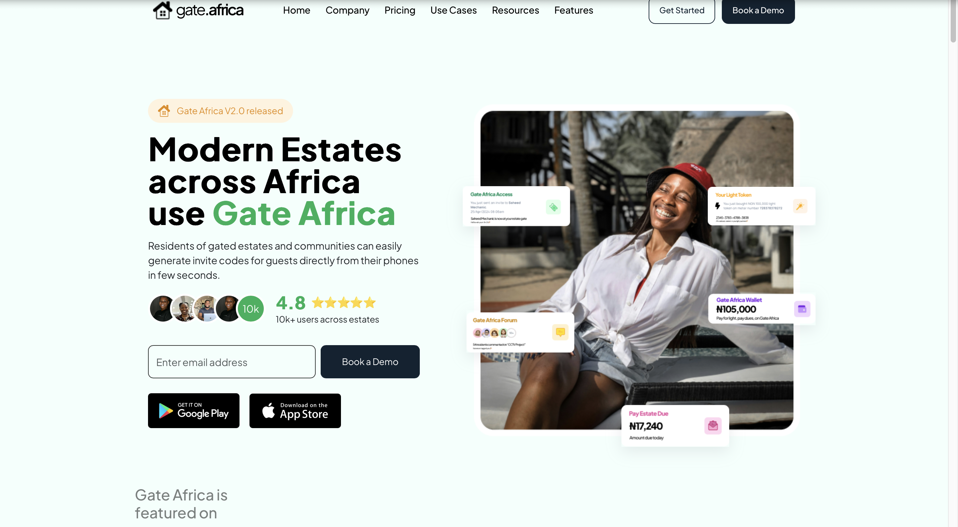

*Figure 2.1 Gate Africa*

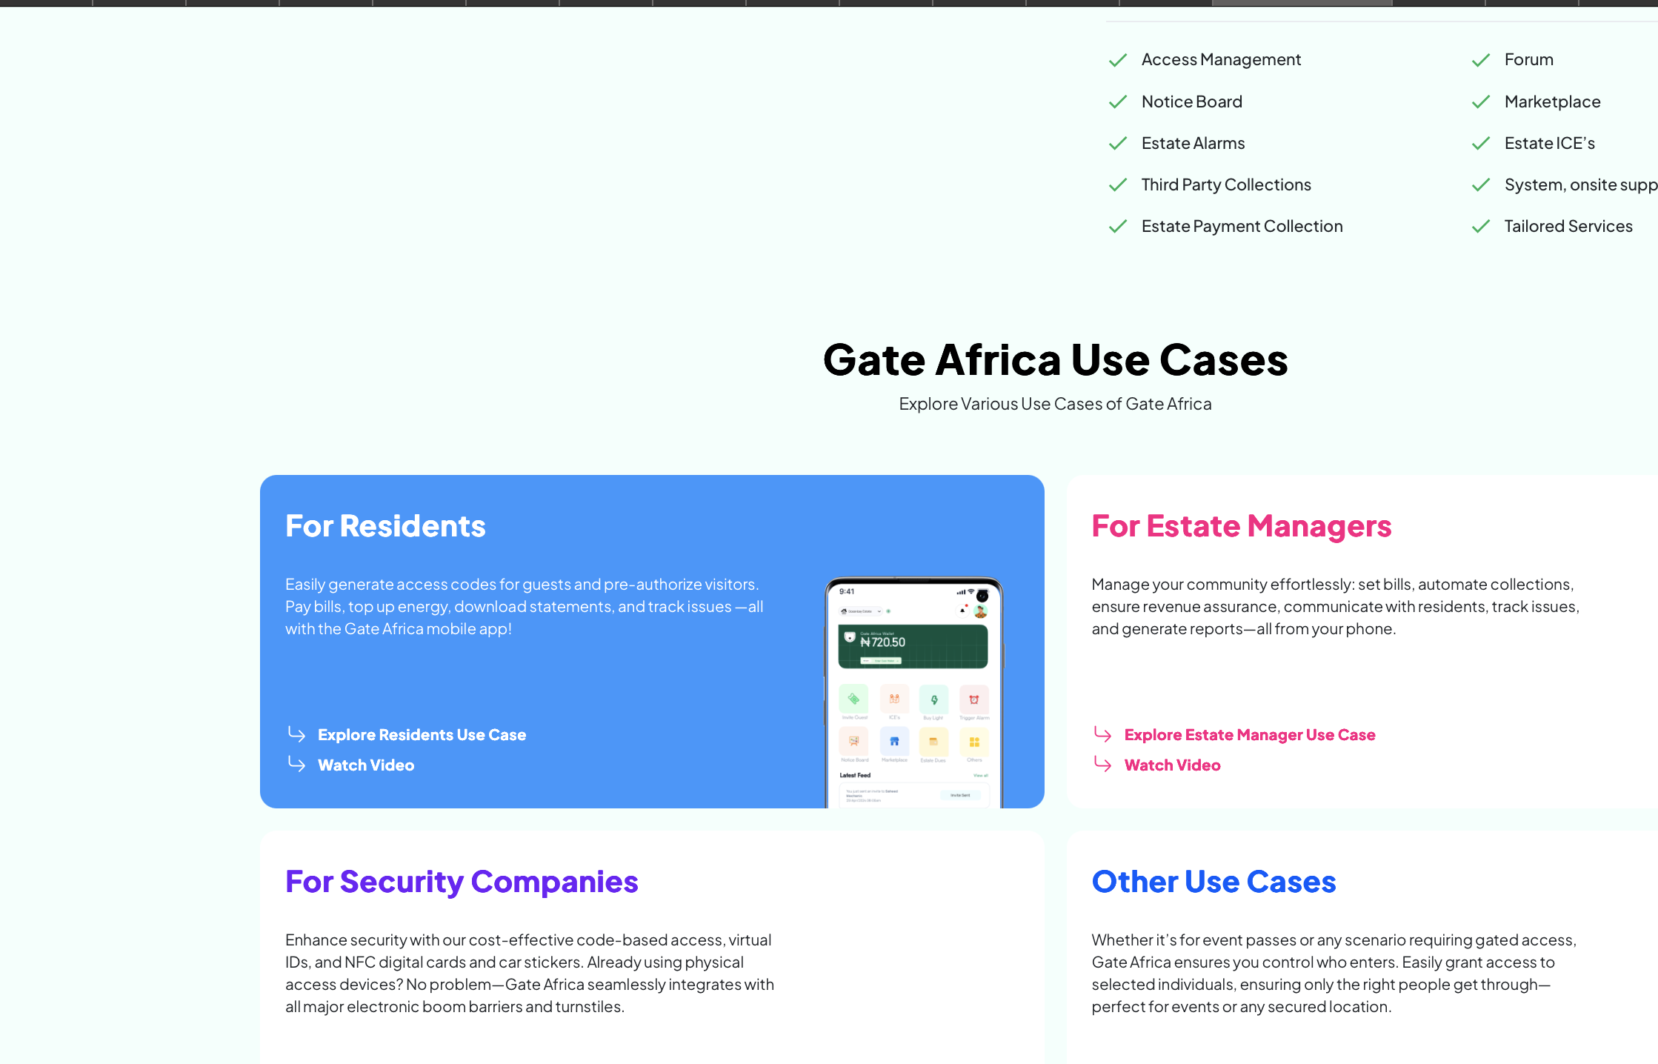

*Figure 2.2 Gate Africa home page*

Table 2.1 Strengths and Weaknesses of Gate Africa

|  |  |  |
| --- | --- | --- |
| **Gate Africa’s Strengths** | **Gate Africa’s Weaknesses** | **Source** |
| shortens the wait at the estate gates. | depends mostly on resident involvement; delays occur for guests without codes | (Olawale & Adeyemi, 2020) |
| enables residents to handle guest approvals directly. | billing and facilities administration interaction is limited. | (Olawale & Adeyemi, 2020) |

### 2.7.2 VENCO Technologies

An advanced estate management software called VENCO (2024), a PropTech startup based in Nigeria, blends digital communication, facility reporting, visitor management, and rent collection. High-end estates and gated communities are its goal.

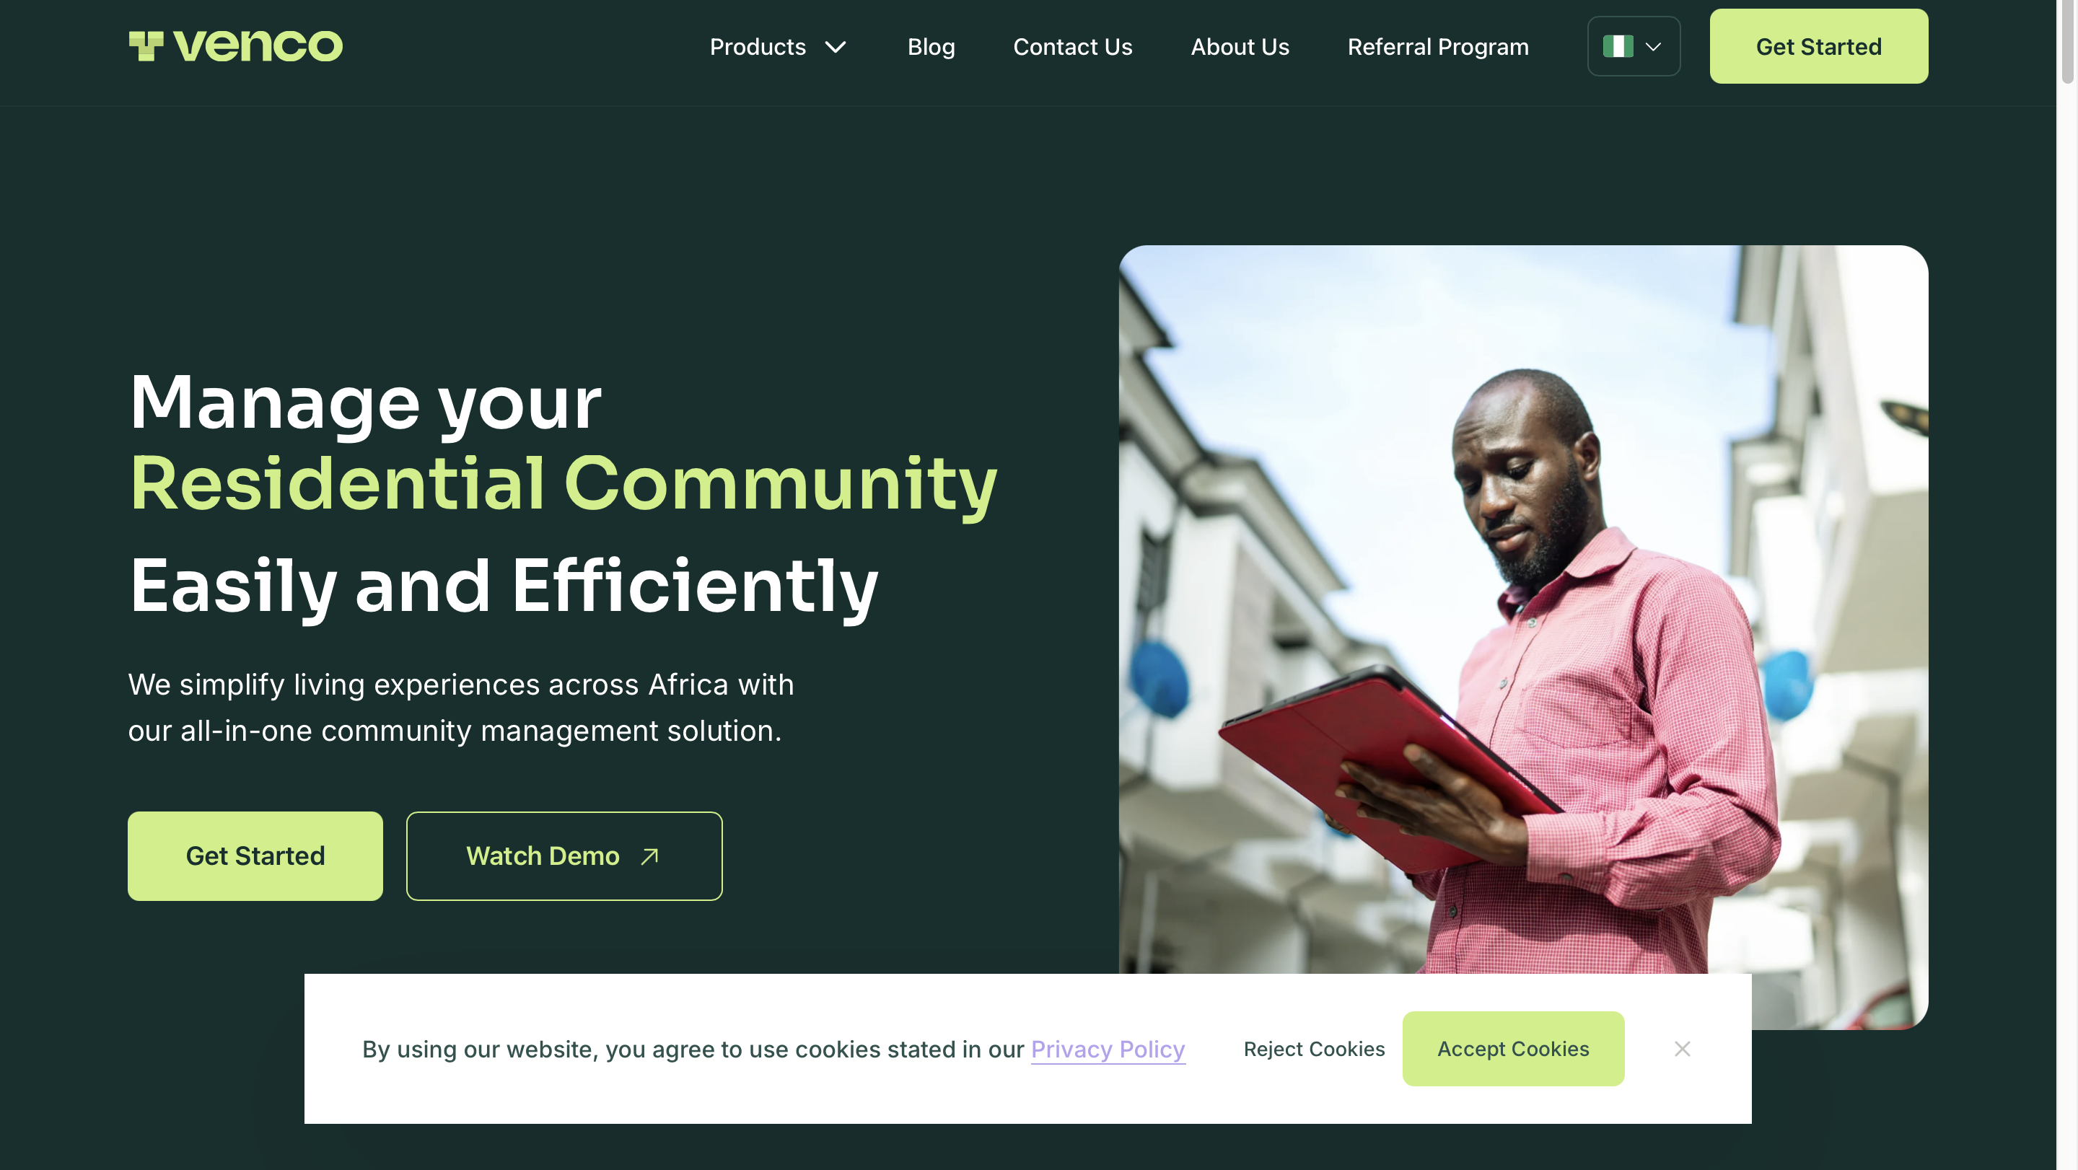

*Figure 2.3*

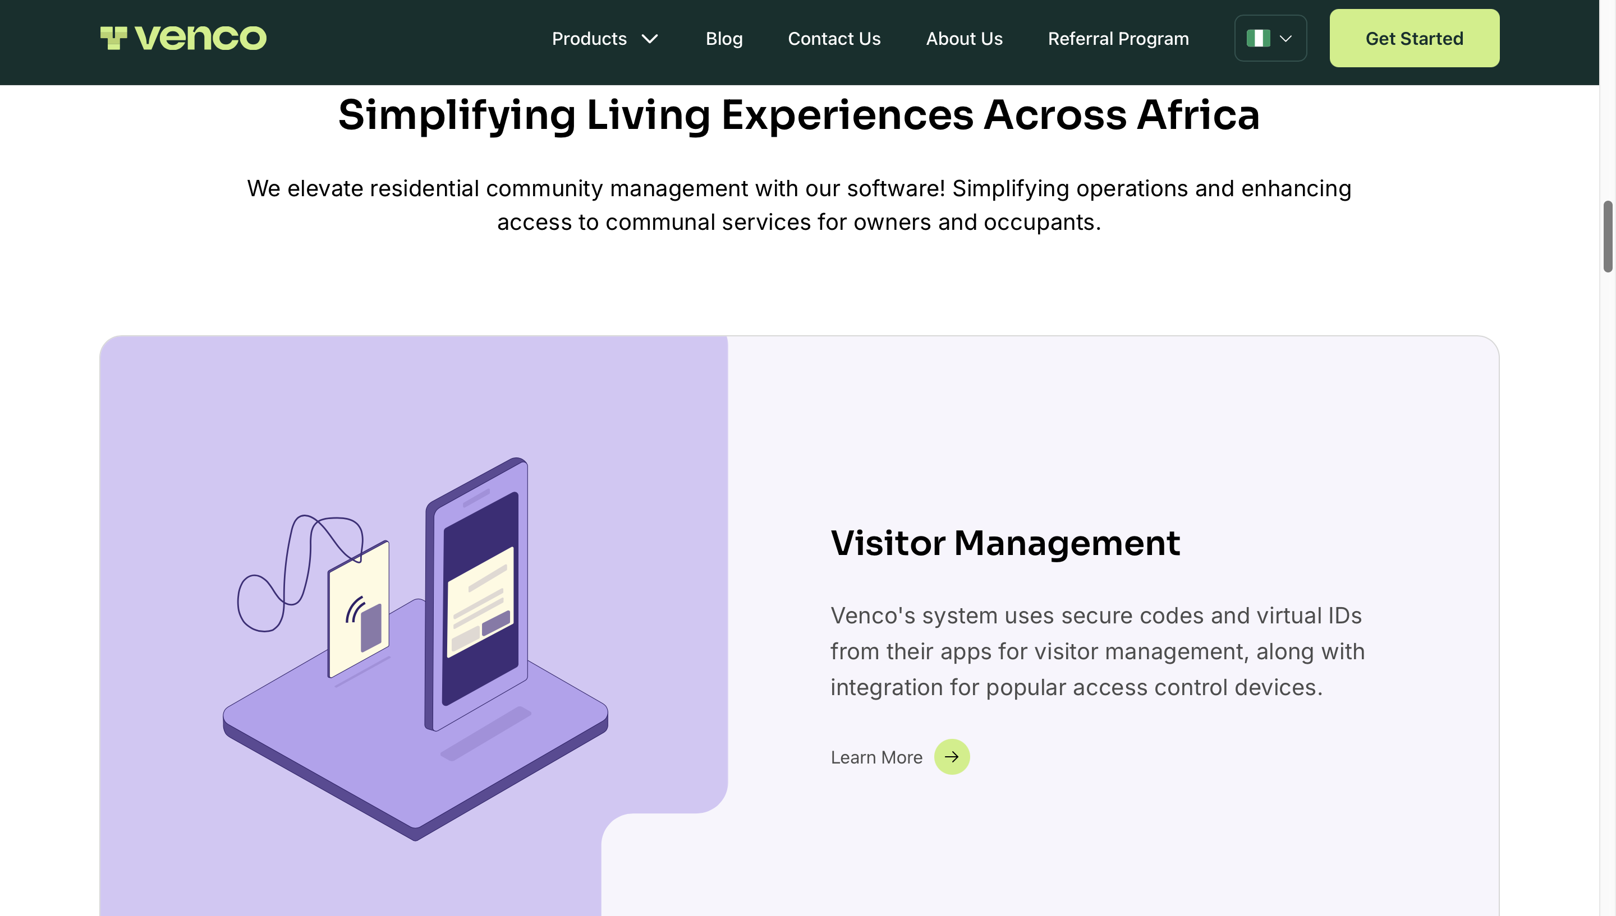

*Figure 2.4 VENCO Technologies Homepage*

### ****Table 2.2: Strengths and Weaknesses of VENCO****

|  |  |  |
| --- | --- | --- |
| **VENCO’s Strengths** | **VENCO’s Weaknesses** | **Source** |
| Comprehensive includes facilities management, billing, and visitor services | expensive subscription, which limits adoption to wealthy homes. | (Nwachukwu & Bello, 2021) |
| An efficient administration dashboard and reporting system | Internet dependent, less useful in places with poor connectivity. | (Nwachukwu & Bello, 2021) |

### 2.7.3 Sylogate Solutions

In Nigeria, Sylogate (2024) used QR codes for temporary passes as part of a low-cost visitor management system development. The project's main goals were middle class estates, accessibility and affordability.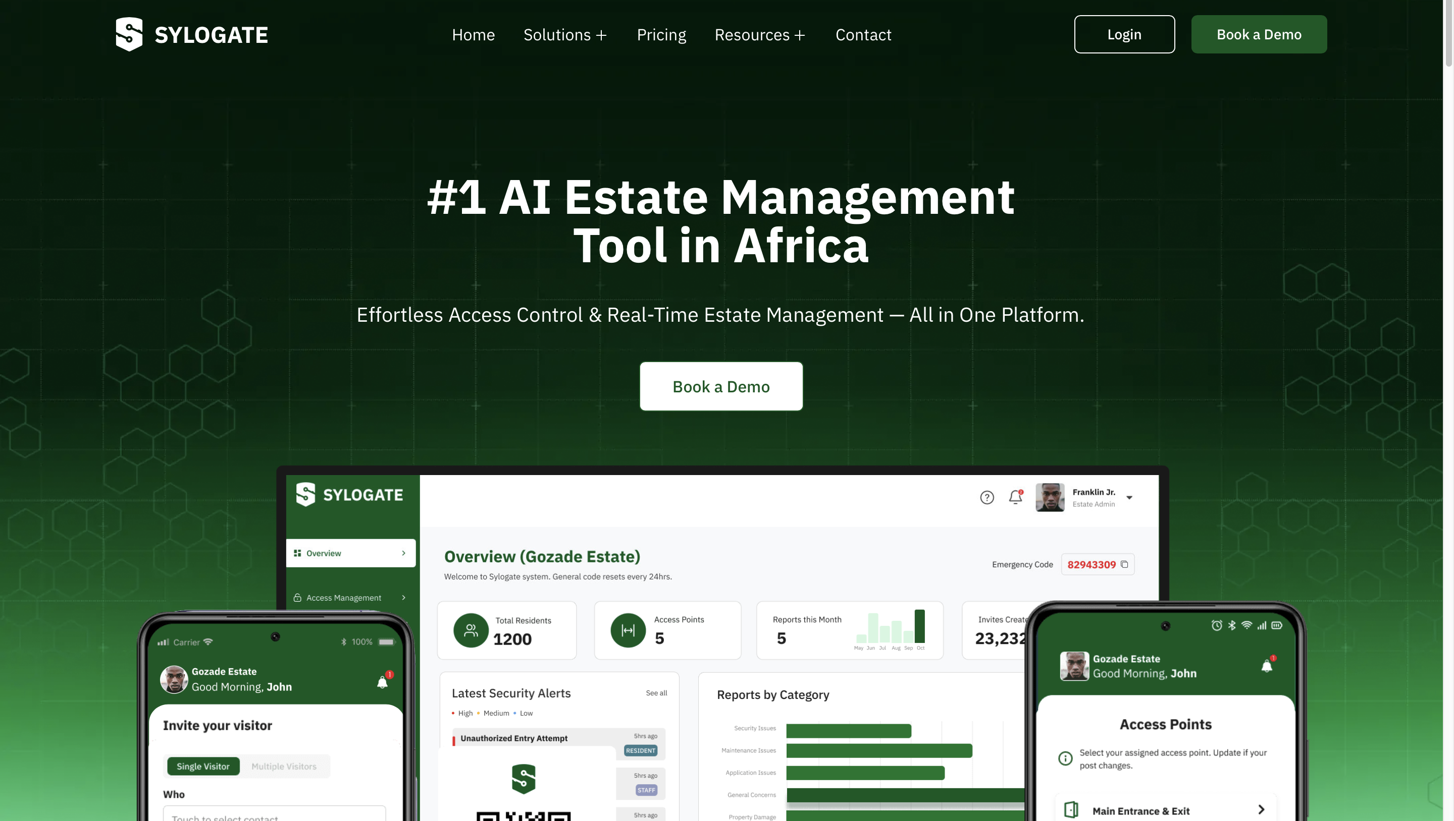

*Figure 2.5 Sylogate Solutions Homepage*

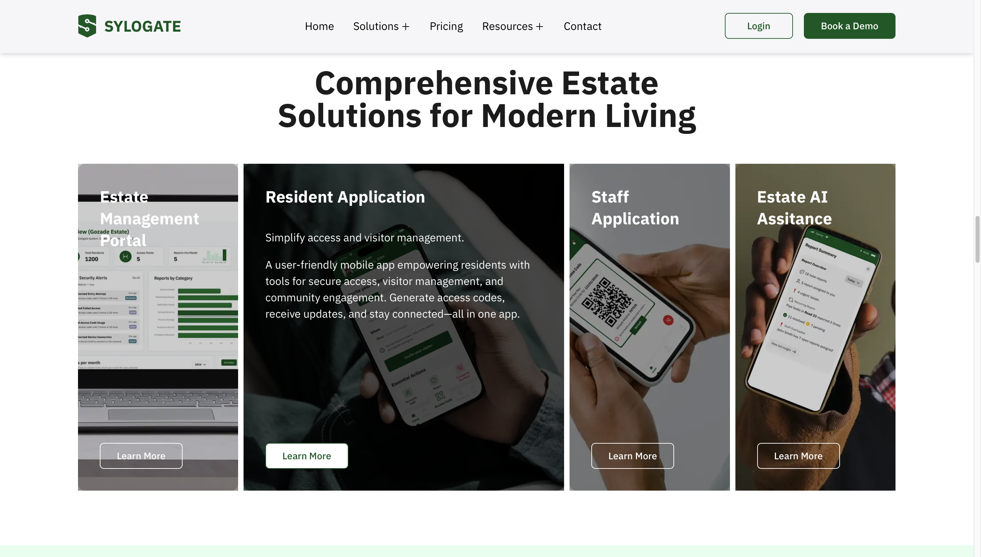

*Figure 2.6 Sylogate Solutions Homepage*

### ****Table 2.3: Strengths and Weaknesses of Sylogate****

|  |  |  |
| --- | --- | --- |
| **Sylogate’s Strengths** | **Sylogate’s Weaknesses** | **Source** |
| Low cost, affordable for a larger  market. | limited scalability for bigger, regularly visited estates. | (Adetayo & Okonkwo, 2022) |
| Simple QR code system minimize the requirement training. | does not include communication or billing features. | (Adetayo & Okonkwo, 2022) |

### 2.7.4 Yardi Breeze

The global cloud based property management system Yardi Breeze (2025) has payment systems, visitor tracking, and tenant communication functions. In the US and Europe, it is used frequently.

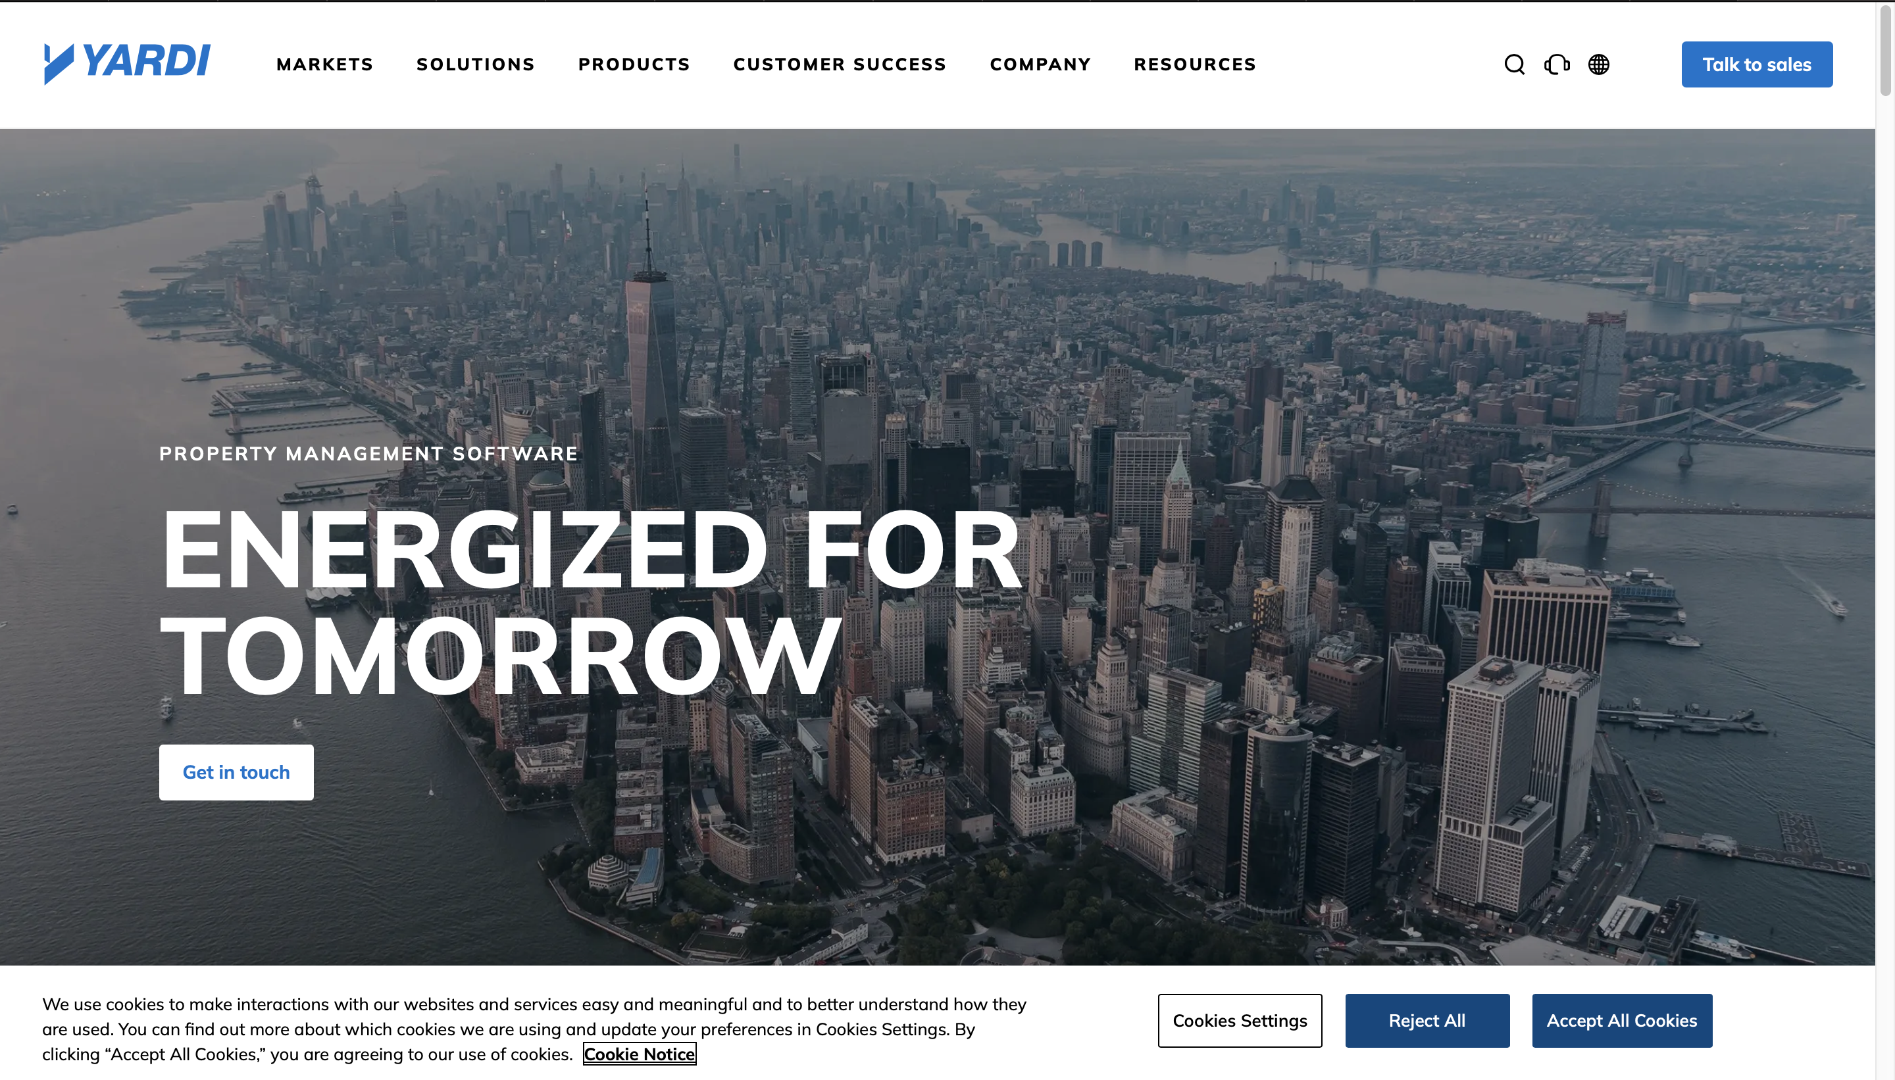

*Figure 2.7 Yardi Breeze Homepage*

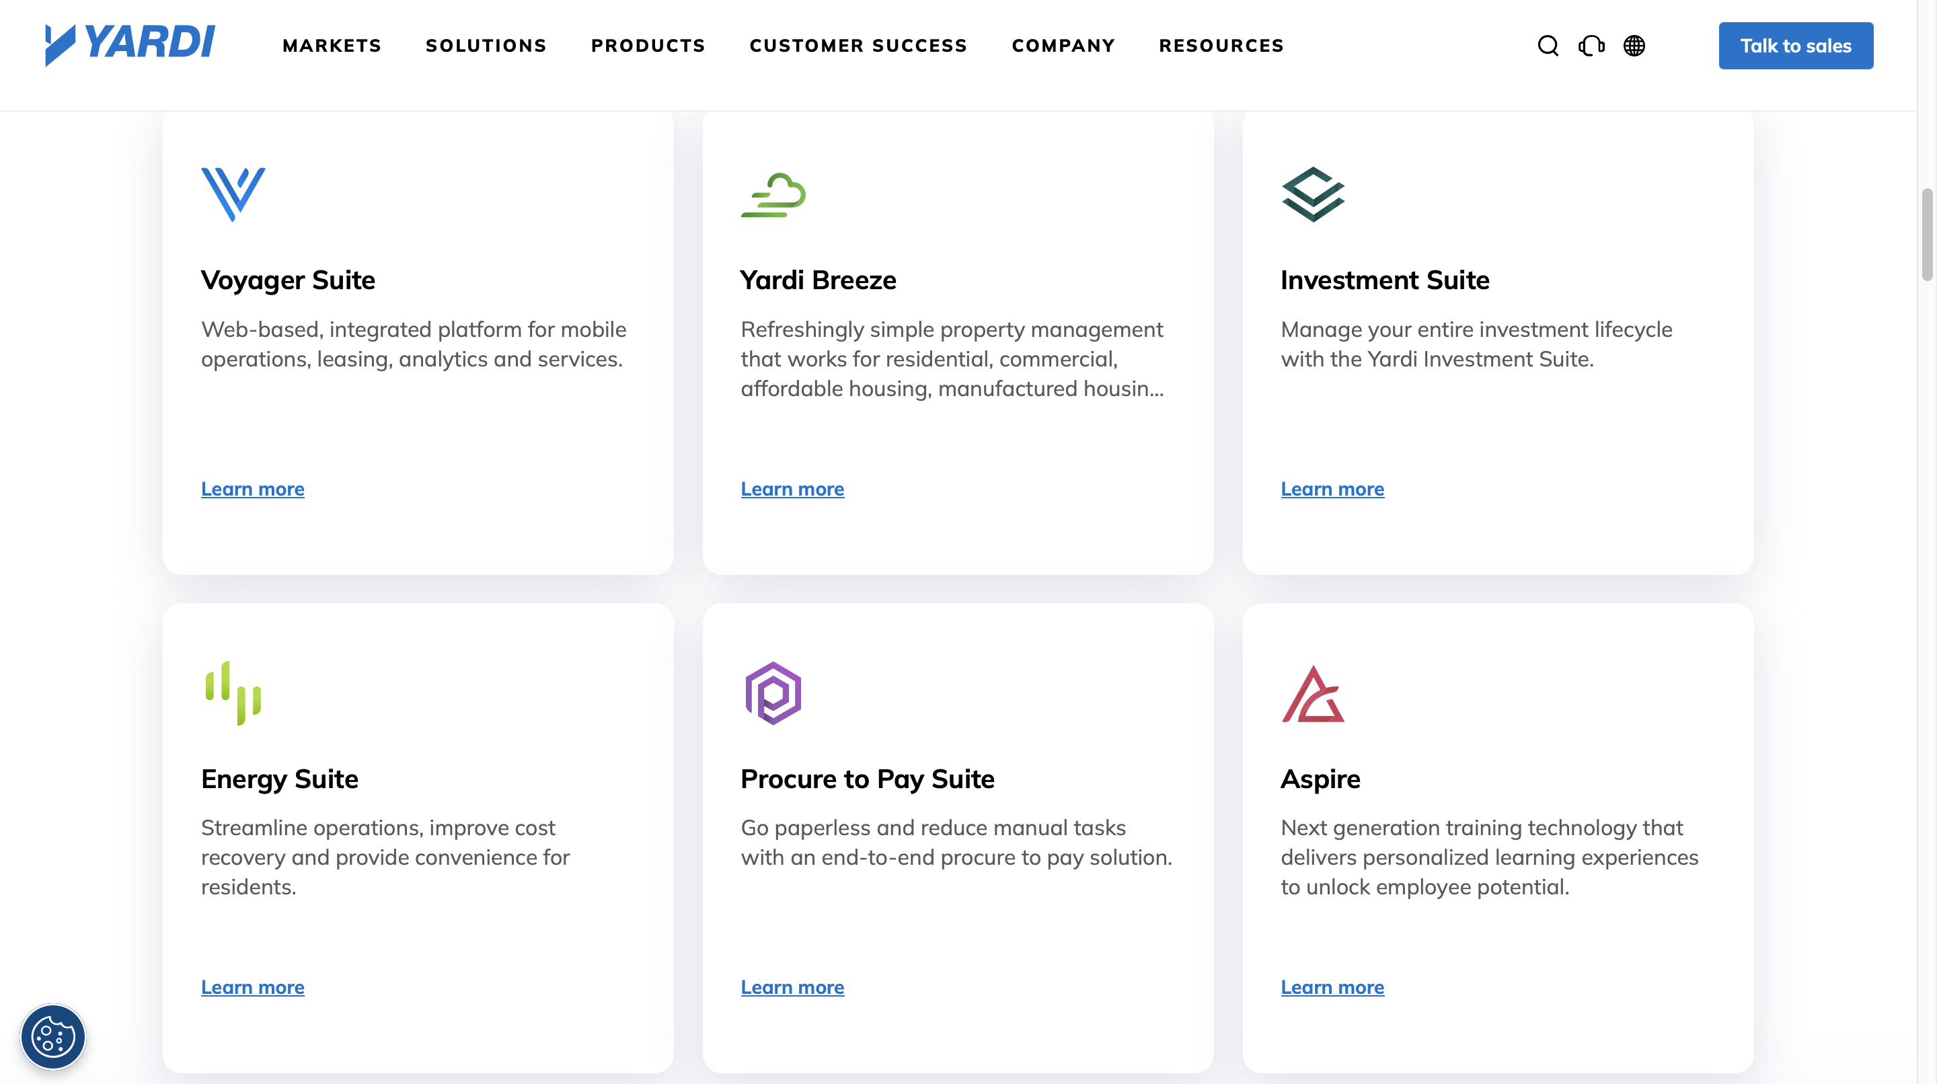

*Figure 2.8 Yardi Breeze Home page*

### ****Table 2.4: Strengths and Weaknesses of Yardi Breeze****

|  |  |  |
| --- | --- | --- |
| **Yardi’s Strengths** | **Yardi’s Weaknesses** | **Source** |
| Cloud storage guarantees the safety and accessibility of data. | Requires dependable, reliable internet. | (Chukwu & Hassan, 2023) |
| comprehensive property management features. | Expensive for markets in Africa. | (Chukwu & Hassan, 2023) |

### 2.7.5 Rees Tech

Figure 1ReesTech Homepage

ReesTech is an international PropTech company focusing on digital property solutions, including visitor management and resident engagement tools.

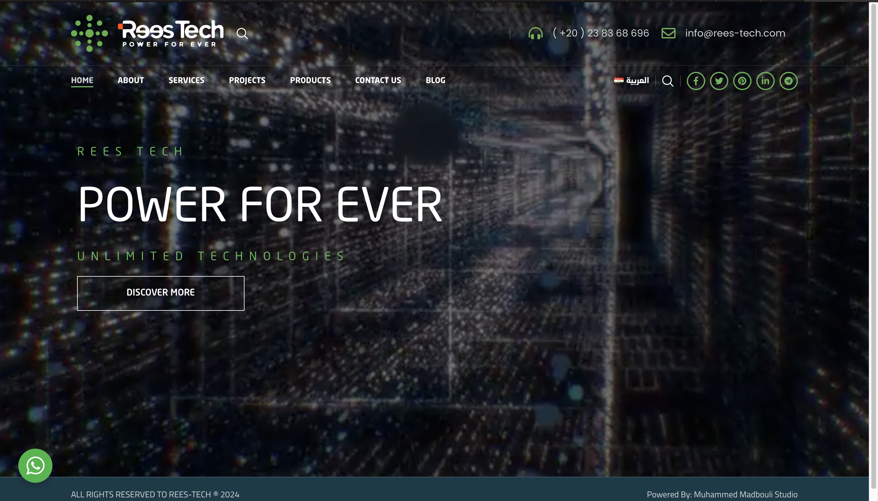

*Figure 2.9 ReesTech Homepage*

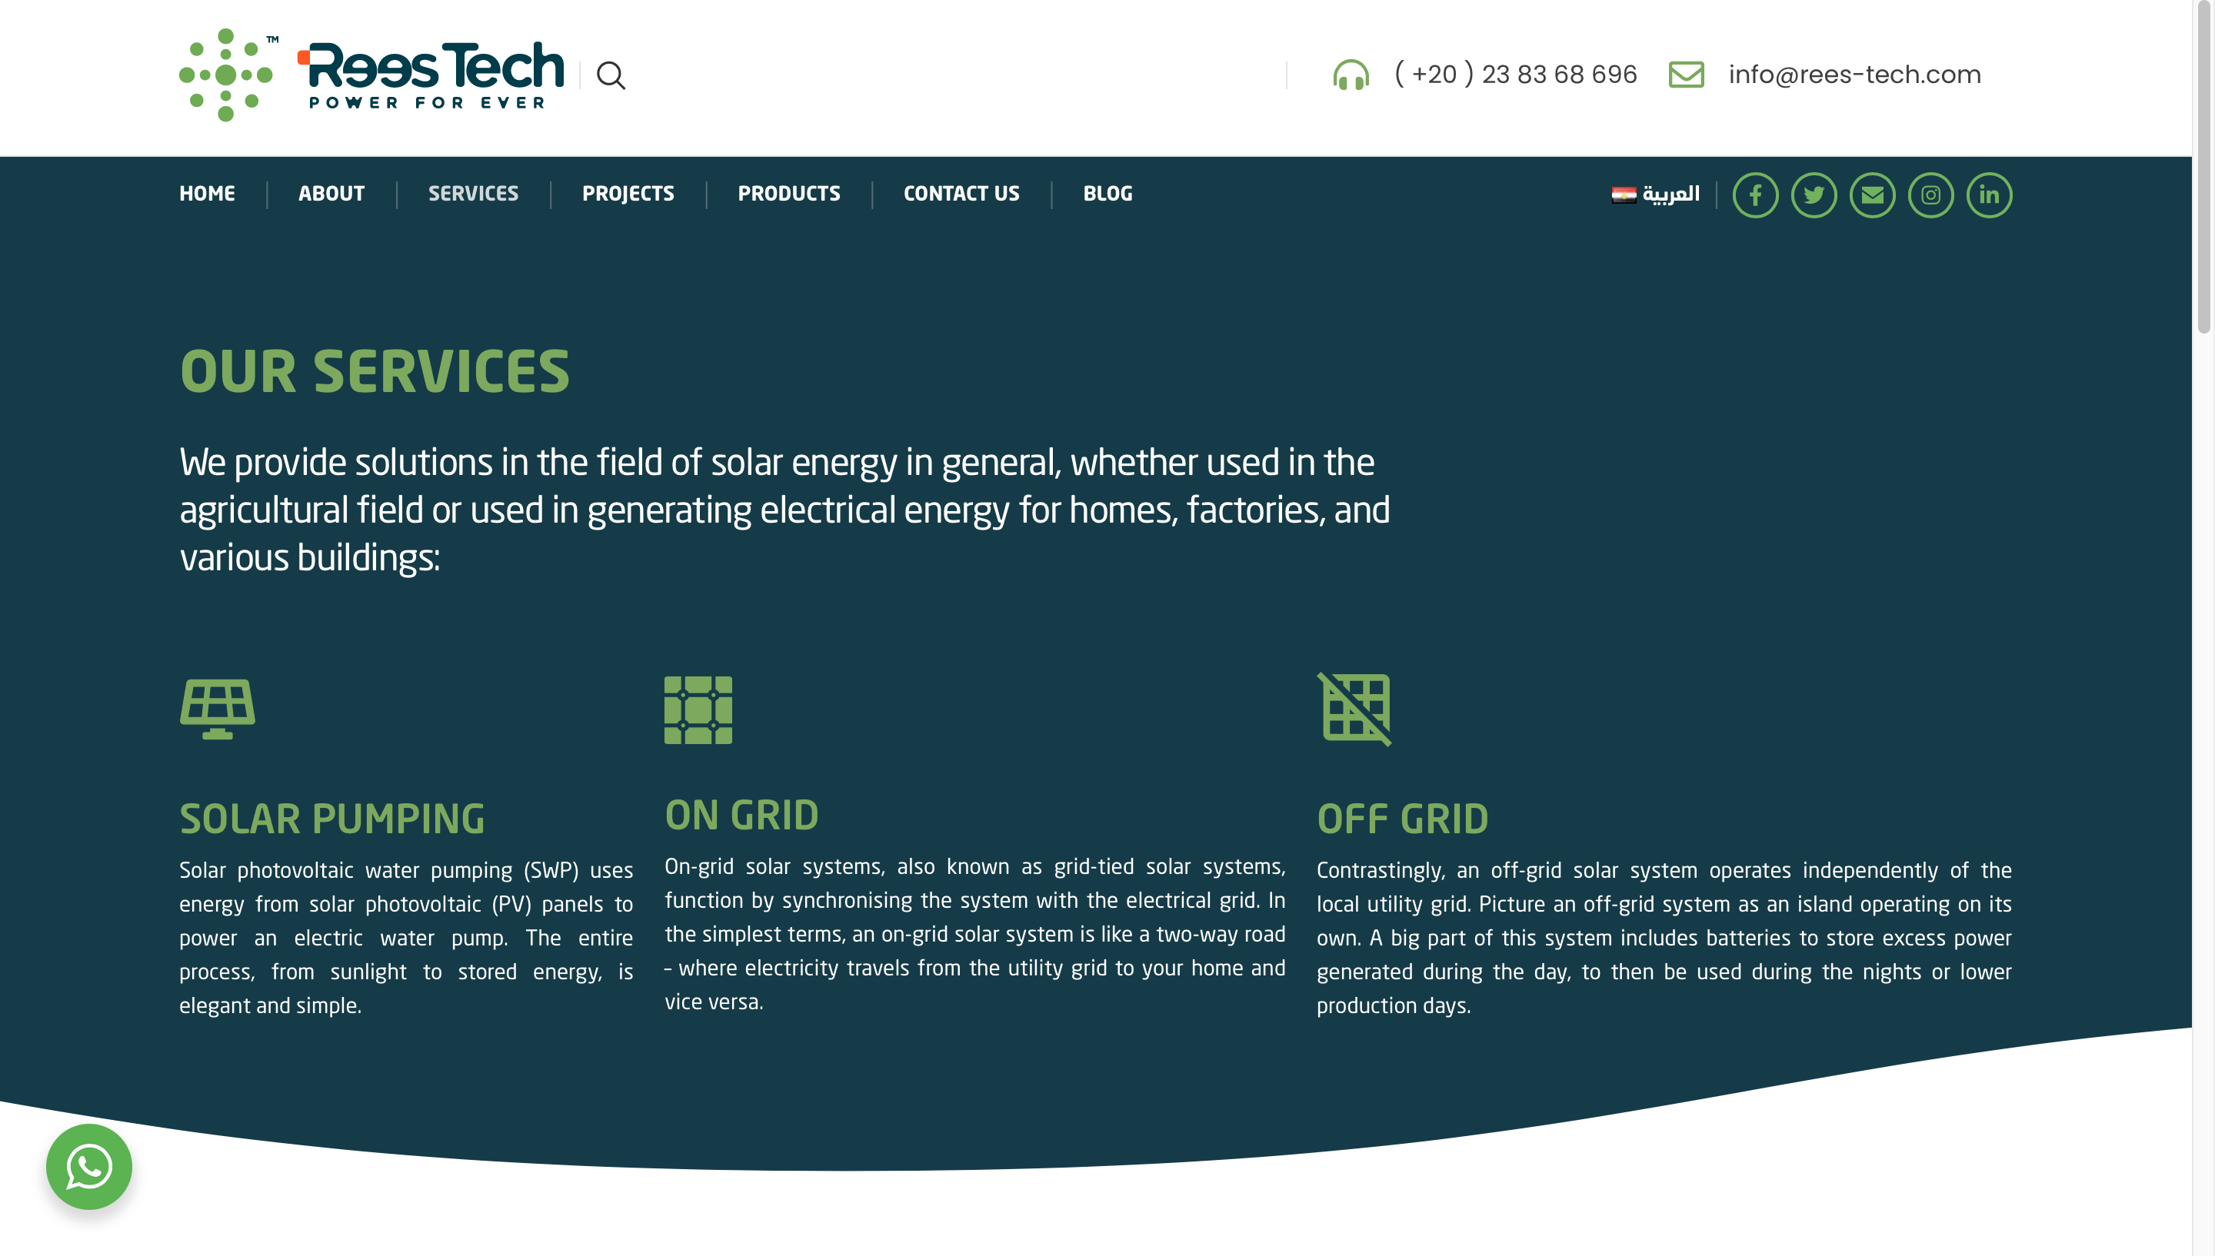

*Figure 2.10 ReesTech Homepage*

### ****Table 2.5: Strengths and Weaknesses of ReesTech****

|  |  |  |
| --- | --- | --- |
| **ReesTech’s Strengths** | **ReesTech’s Weaknesses** | **Source** |
| For large properties, it is expandable and well-organized. | Costly and inaccessible to low-income estates. | (Adebayo & Yusuf, 2024) |
| powerful data analytics features and smooth integration. | IT support and training are necessary for this complex system. | (Adebayo & Yusuf, 2024) |

### Table 2.6 Summary of the Related Works

|  |  |  |  |
| --- | --- | --- | --- |
| System/Author(s) | Strengths | Weaknesses | Source |
| |  | | --- | | Gate Africa | | |  | | --- | | shortens wait times and gives residents greater control | | |  | | --- | | mainly depends on resident involvement | | |  | | --- | | Olawale & Adeyemi, 2020 | |
| |  | | --- | | VENCO Technologies |  |  | | --- | |  | | Complete billing integration | costly and reliant on the internet | Nwachukwu & Bello, 2021 |
| Sylogate Solutions | Simple and cost-effective QR system | Scalability issues for larger estates | Adetayo & Okonkwo, 2022 |
| Yardi Breeze | Safe cloud based storage | very expensive for African markets | Chukwu & Hassan, 2023 |
| ReesTech | Strong analytics tools that are flexible | Complex, needs assistance from IT | Adebayo & Yusuf, 2024 |
| Envoy Visitor | Modern, smooth interface | High subscription fee | Wei & Sun, 2024 |
| ButterflyMX | Mobile entry intercom | need reliable infrastructure. | Helixbeat Research, 2022 |
| Proptia | Strong reporting, safe platform | Subscription are too costly in Africa | Chen & Ibrahim, 2025 |
| Kisi Access | Entry using mobile smartphone | Reliance on IoT hardware | Zhang & Liu, 2020 |
| iLobby | A visitor solution that is compliance focused | needs consistent cloud connectivity. | Chowdhury & Patel, 2023 |
| EasyRoster (South Africa) | combines the guest staff roster | centered on businesses rather than estates | Mensah & Boateng, 2024 |
| EstateMate (S. Africa) | Approvals and communication driven by residents | Limited acceptance outside of expensive estates | Daramola & Usman, 2024 |
| Digital Gates (Kenya) | Low cost, SMS based system | depends on cellular networks | Ibrahim & Musa, 2023 |
| VENCO Pilot (Nigeria) | A complete system for tenants and visitors | Limited to luxurious estates | Nwachukwu & Bello, 2021 |
| Sylogate Pilot (Nigeria) | Feature and affordability balance | Not yet implemented globally | Adetayo & Okonkwo, 2022 |

## 2.8 Summary

The literature review demonstrates a consistent shift from manual visitor registration to advanced PropTech systems. Global innovations like blockchain, artificial intelligence, QR codes, and cloud based systems are prevalent, while localised adaptations are highlighted by African companies like Gate Africa, VENCO, and Sylogate Solutions. Global solutions like Yardi Breeze, Proptia, and goAccess demonstrate how estate visitation fits into larger ecosystems for property management.   
The purpose of this study is to create a customized estate visitation system that maintains a balance between security, efficiency, and compliance in the Nigerian setting, and these gaps support that goal.

# CHAPTER 3

# REQUIREMENTS ANALYSIS AND DESIGN

## 3.1 Overview

The project's requirements gathering procedure is discussed in this chapter. It will make the proposed strategy, model, and application architecture visible. The system design and both functional and non-functional requirements will also be covered in this chapter.

## 3.2 Proposed Model

The Agile methodology is a project management technique that promotes ongoing cooperation and development and divides the project into phases. Because implementing the agile technique offers numerous advantages, it has been chosen for this project. Agile's flexibility will enable the project to adjust in response to stakeholder feedback and market trends, guaranteeing that the platform remains applicable and valuable. As the project develops, it will be simpler to incorporate new features and technologies according to this method's ability to make improvements gradually. Agile also places a strong emphasis on user interaction, emphasizing ongoing feedback to create a platform that genuinely meets user demands.

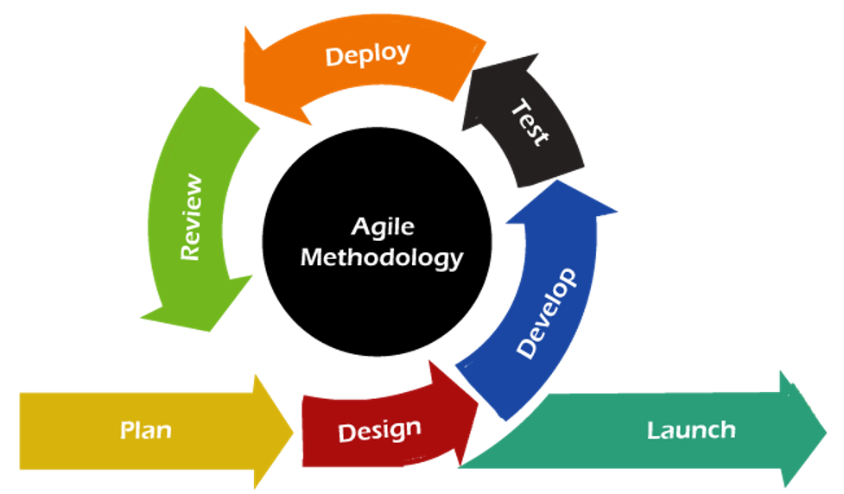

Figure 3.1: Agile Development(JavaTPoint)

## 3.3 Methodology

The agile methodology has been chosen as the project's guiding structure. An iterative approach to software development, the Agile methodology provides a flexible means of meeting changing requirements. Incremental delivery, customer interaction, simplicity, embracing change, and people rather than processes are some of its guiding principles.  
Planning, design, implementation, testing, and maintenance are all included in the Agile technique, which usually divides a project into smaller units. Agile requires ongoing feedback from stakeholders. Because the project's implementation is centered on the feedback of residents, administrators, and security staff, the Estate Visitation System therefore continues to live up to user expectations.

3.3.1 Method 1 (Interview)

Key stakeholders, such as residents, security guards, and estate administrators, were interviewed. These interviews were conducted in order to obtain an initial understanding of the difficulties associated with the present manual visitor management procedure. Concerns were raised by administrators over imprecise documentation and the challenge of making notifications on schedule. Residents drew attention to entry gate delays, which are frequently the result of misunderstandings between residents and security personnel. The inefficiencies of paper-based logs, which are prone to loss and manipulation, were brought to the attention of security staff. All things considered, the interviews reaffirmed the necessity of an automated, dependable, and safe estate visiting system.

3.3.2 Method 2 (Questionnaire)

Residents and estate employees also received standardized surveys in addition to interviews. The purpose of the questionnaires was to gather quantitative information about user expectations, experiences, and readiness to use a digital visiting platform. Wait times at entry gates, contentment with the security procedures in place, and interest in features like QR code visitor passes, push notifications, and emergency alerts were among the topics covered in the questions. The majority of participants expressed support for a computerized alternative that would increase accountability and efficiency in guest management, indicating general dissatisfaction with the current manual system.

## 3.4 Tools and Techniques

This section outlines the tools and techniques that are essential to the successful delivery of this project. They are as follows:

1. **Documentation tools:** Google Docs, MS Word and Notepad were the tools selected to facilitate the documentation of this project.
2. **Prototyping and Design Tools:** The design and prototyping tools chosen for this project include StarUML, Workbench, and draw.io.
3. **Text Editor:** Visual Studio code.
4. **Version Control System:** Git Hub has been chosen as the platform selected for this system's version control.
5. **Programming Languages and Frameworks:** Python, Django Rest Framework, Next.js, React Native.

## 3.5 Ethical Consideration

## Transparency, accountability, and user privacy and data protection are the main ethical factors. Firm encryption measures will be used to ensure that user data and information are protected with the highest care. Because the user is well informed about how the Estate Visitation System functions to provide visitor management, emergency reporting, and notifications, there will be accountability and transparency.

## 3.6 Requirement Analysis

The questionnaire and performed interview act as the foundation for the requirement analysis. We were able to identify a critical need from the resident's point of view: an interface that is mobile responsive and easy to use. Access to estate announcements, real-time notifications, and fast visitor approvals were all among the user requirements. Similarly, a user-friendly dashboard that facilitates visitor verification, entry status checks, and incident recording was one of the needs determined from the viewpoint of the security staff. Furthermore, our analysis demonstrated that in order to manage a potentially high number of residents and visitors, the system's scalability and efficiency when the user base grows must be given a significant level of priority.

## 3.7 Requirement Specifications

The Estate Visitation System's functional and non-functional requirements will be outlined in this section. Based on this, we create a clear, simple, and solid structure that will serve as the foundation for the system's development.

### 3.7.1 Functional Requirement Specifications

Table 3.1 Functional Requirement Specifications

|  |  |  |
| --- | --- | --- |
| **Req. No** | **Description** | **Type** |
| R-001 | The resident shall be able to register and log in. | Functional |
| R-002 | The residents shall be able to generate visitor pass using QR codes or OTP. | Functional |
| R-003 | The security personnel shall be able to scan and verify visitor codes at the gate. | Functional |
| R-004 | The Admin shall be able to revoke or approve visitor access at the gate. | Functional |
| R-005 | The resident shall be able to receive real time notification upon arrival of their visitor. | Functional |
| R-006 | The resident shall be able to report any emergency incident. | Functional |
| R-007 | The admin shall be able to send estate wide notification to all users. | Functional |
| R-008 | The admin shall be. Able to manage residents data and records. | Functional |
| R-009 | The system shall be able to provide a dashboard for admin to monitor estate activities. | Functional |

### 3.7.2 Non-Functional Requirement Specifications

### Table 3.2 Non-Functional Requirement Specifications

|  |  |  |
| --- | --- | --- |
| **Req. No** | **Description** | **Type** |
| R-001 | The system shall ensure user privacy and data security. | Security |
| R-002 | The system shall be available 24/7. | Availability |
| R-003 | The system shall be mobile responsive. | Usability |
| R-004 | The system shall be good looking and have user friendly interface. | Usability |
| R-005 | The system shall be able to handle large users without system degradation. | Performance |
| R-006 | The system shall adhere to provided guidelines regarding user data protection. | Compliance |

## 3.8 System Design

## An extensive overview of the key components that compose the Estate Visitation System is given in this section. They are as follows:

## I. SIGNUP/REGISTRATION: Account creation will be possible for new users of the system, including administrators, security guards, and residents. Residents will register with their personal information and house data, and the system administrator will register administrators and security staff with their designated tasks. II. LOG IN: Users who have already registered can use their login credentials to access this feature. After logging in, individuals will be taken to their respective dashboards based on the roles they were assigned, which may be resident, security, or admin.

III. VISITOR MANAGEMENT: By creating one-time or multi-use QR/barcode passes, this feature allows residents to pre-register their guests. Before allowing entry, security guards will scan these passes at the gate to confirm the visitor's identification. All visitor information, timings, and the person who authorized them will be recorded by the system.

IV. EMERGENCY REPORTING: Through the app, residents will be able to report issues like medical crises, fire outbreaks, and break-in attempts. To facilitate prompt action, the system will immediately alert administrators .

V. ANNOUNCEMENT AND NOTIFICATIONS: Administrators will be able to send estate-wide announcements or changes to all registered users. Residents and security staff will receive real time push notifications on important updates and emergency alarms.

VI. HANDYMAN/SERVICE REQUESTS: This module enables residents to submit requests for handyman services, including repairs, plumbing, and electrical work. Administrators can oversee and assign these requests to available service providers while monitoring their progress.

VII. DASHBOARD: A customized dashboard will be provided for every user role. Residents have access to announcements, service requests, and visitor history. While administrators may check statistics, manage users, and keep an eye on system activity, security staff can view daily visitor records.

3.8.1 Application Architecture  
The architecture of the application is contained in this section. It will demonstrate the communication between the client and server sides. The data flow between the front-end and the back-end is shown in Figure 4.

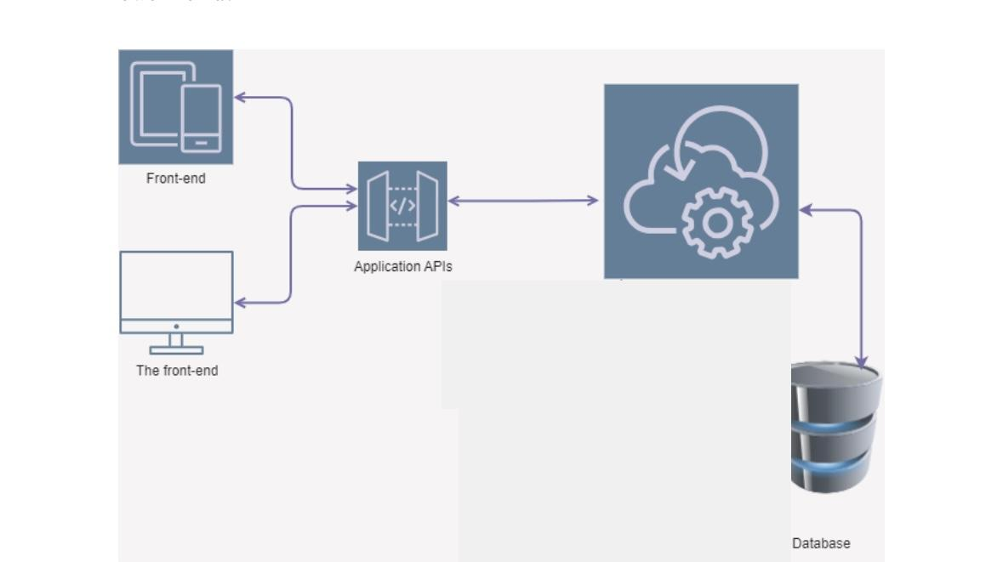

The Back-end

Figure 3.2 Application Architecture

### 3.8.2 Use Case

The roles of each actor in the Estate Visitation System are illustrated in the use case diagram. The visitor, the resident, the security guard, and the estate administrator are the primary actors. To carry out duties that guarantee safe and effective visitor management in the estate, each actor communicates with the system.

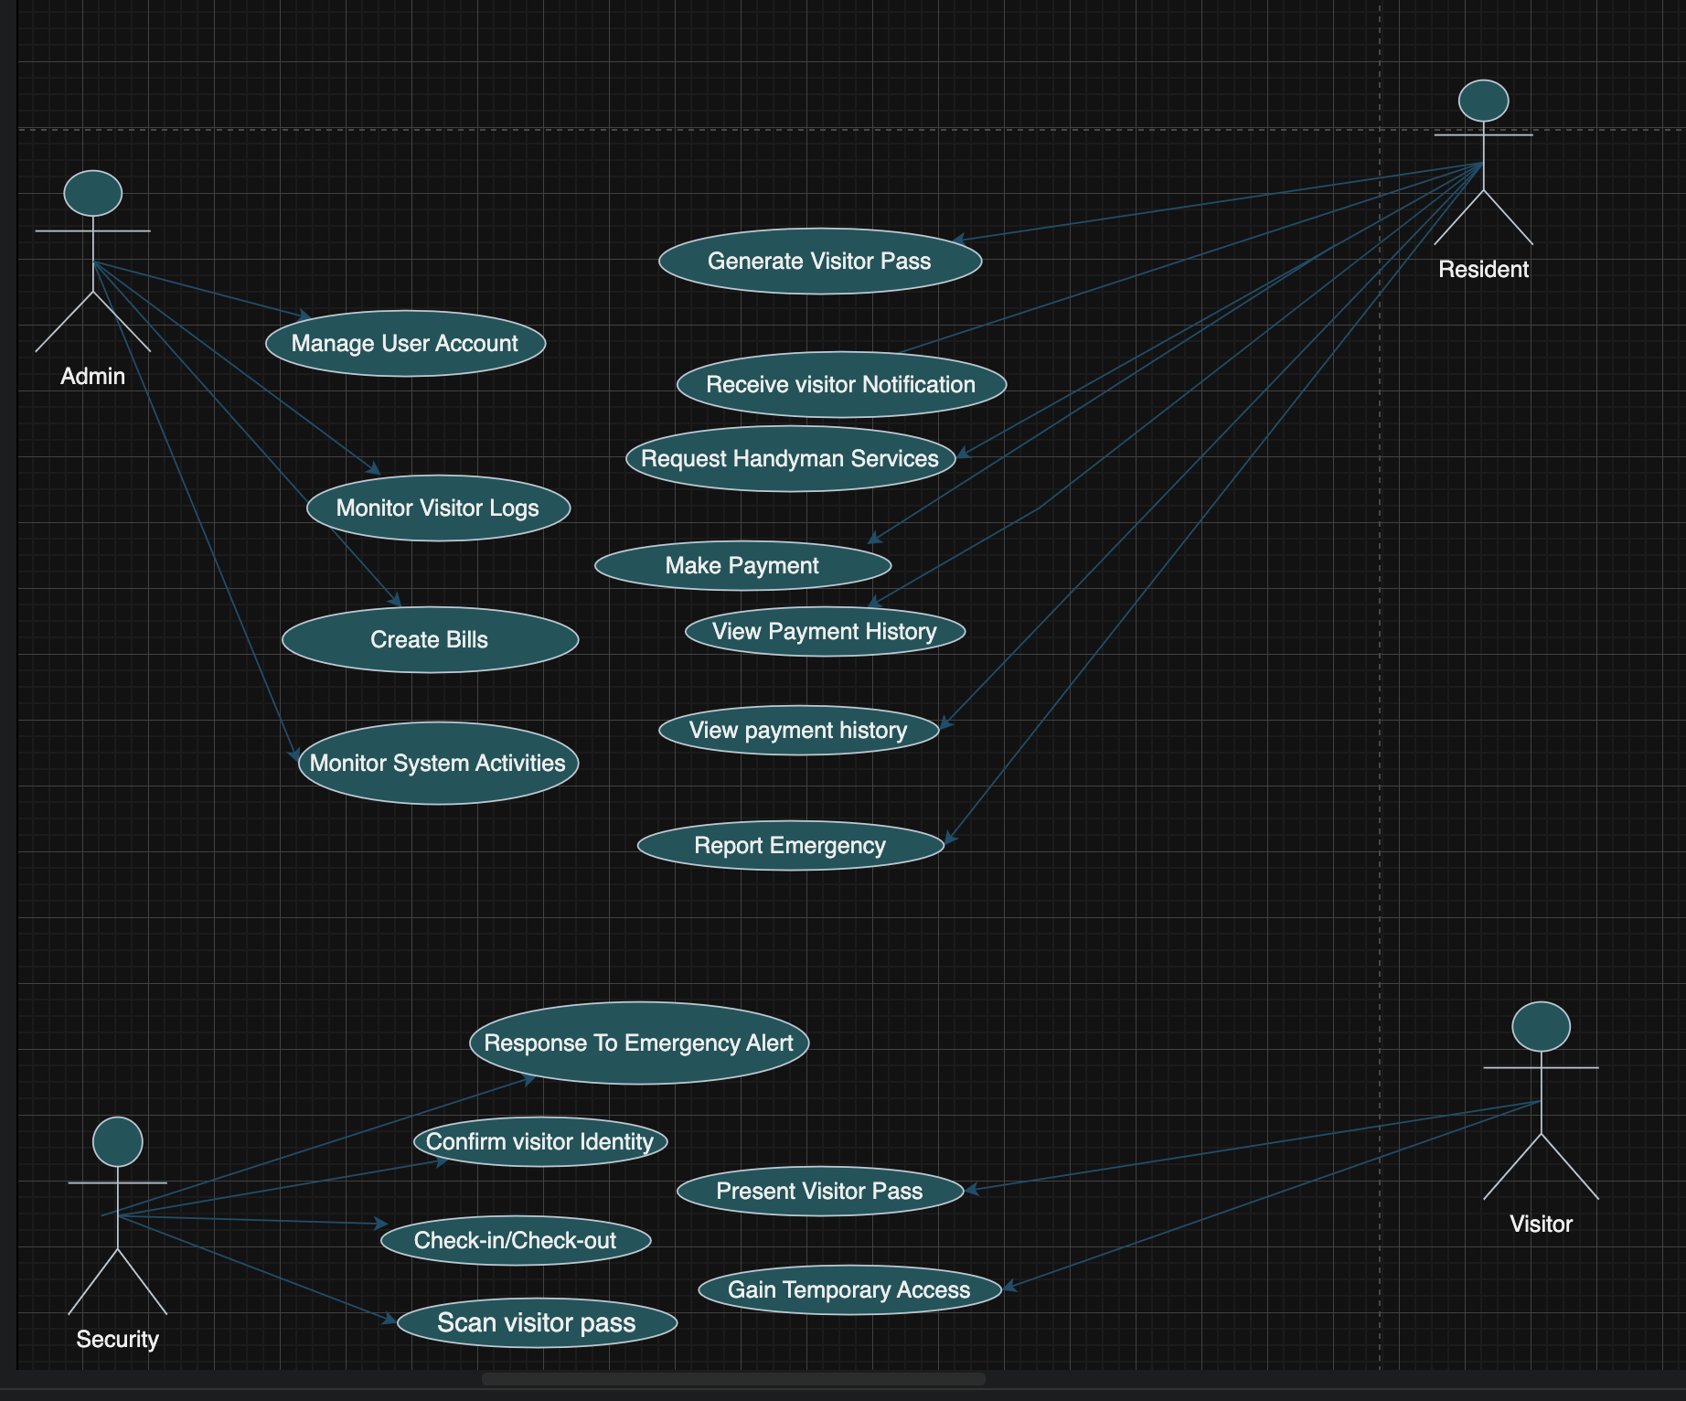

Figure 3.3 Use Case Diagram

Table 3.3 Use case description for visitor check in (Security)

|  |  |  |
| --- | --- | --- |
| Use Case: | Register | |
| Description | This use case describes how security admin register’s visitor when they arrive at the gate. | |
| Actors | Security | |
| Preconditions: | Security logged into the system. | |
| Postconditions: | If visitor check in is successful, it saves the record to the system. | |
| Main flow: | User:  Security clicks check in visitor | System:  The system validate the provided information |
| Exception condition: | Missing or invalid QR code denies visitor’s check in | |

Table3.4 Use case description for Resident

|  |  |  |
| --- | --- | --- |
| Use case | Approve visitor entry | |
| Description | This use case describes how a resident approves or decline request by visitor. | |
| Actors | Residents | |
| Preconditions: | Resident log into the app and accept or reject request | |
| Postconditions: | If approval is granted, the visitor is allowed entry, if declined, visitor is denied access. | |
| Main flow: | User:  Resident receive notification of visitor’s request.  Resident view and either approve or decline. | System:  If approved the system update visitor to approved.  If declined the system update visitor to decline. |
| Exception condition: | If resident does not request within set time the request may expire. | |

Table 3.5 Use case description for managing user's accounts

|  |  |  |
| --- | --- | --- |
| Use case | Manage user’s account | |
| Description | This use case describes how the Admin manages accounts for residents and security. | |
| Actors | Main Estate Admin | |
| Preconditions: | Admin logged into the system | |
| Postconditions: | If the action succeeds the users account are created updated or deleted as required. If the action fails, The system state remain unchanged. | |
| Main flow: | User:  Admin navigate to the user management.  Admin create, update or delete user.  Admin enter’s or edit the required user’s details. | System:  The system validate the provided details.  The system confirms and update the user’s list. |
| Exception condition: | If required details are missing or invalid, the system display’s error message. Admin can retry or cancel. | |

### 3.8.3 Data Design

The following tables. Provide. Details on some of the entities. That will be stored in the database.

### Table 3.6 Data Dictionary for Visitor Table

|  |  |  |  |
| --- | --- | --- | --- |
| **Attribute Name** | **Type** | **Required** | **PK / FK** |
| Visitor_id | Integer | Yes | PK |
| First_name | Varchar(45) | Yes | - |
| Last_name | Varchar(45) | Yes | - |
| Phone | Varchar(15) | Yes | - |
| Email | Varchar(45) | No | - |
| Identification_type | Varchar(45) | Yes | - |
| Identification_number | Varchar(45) | Yes | - |

### Table 3.7 Data Dictionary for Resident Table

|  |  |  |  |
| --- | --- | --- | --- |
| **Attribute Name** | **Type** | **Required** | **PK / FK** |
| Resident_id | Integer | Yes | PK |
| First_name | Varchar(45) | Yes | - |
| Last_name | Varchar(45) | Yes | - |
| Phone | Varchar(15) | Yes | - |
| Email | Varchar(45) | Yes | - |
| House_number | Varchar(20) | Yes | - |
| Password | Varchar(45) | Yes | - |

### Table 3.8 Data Dictionary for Security Personnel Table

|  |  |  |  |  |  |
| --- | --- | --- | --- | --- | --- |
| |  | | --- | | **Attribute Name** | | **Type** | **Required** | |  | | --- | | **PK / FK** |   **PK/FK** |
| Security_id | Integer | Yes | Pk |
| First_name | Varchar(45) | Yes | - |
| Last_name | Varchar(45) | Yes | - |
| Phone | Varchar(15) | Yes | - |
| Email | Varchar(45) | Yes | - |
| Shift_schedule | Varchar(45) | Yes | - |
| Password | Varchar(45) | Yes | - |

### Table 3.9 Data Dictionary for Visitation Table

|  |  |  |  |
| --- | --- | --- | --- |
| **Attribute Name** | **Type** | **Required** | **PK / FK** |
| Visit_id | Integer | Yes | PK |
| Visitor_id | Integer | Yes | FK |
| Resident_id | Integer | Yes | FK |
| Entry_pass_code | Varchar(100) | Yes | - |
| Status | Varchar(20) | Yes | - |
| Scheduled_time | DateTime | Yes | - |
| Check_in_time | DateTime | No | - |
| Check_out_time | DateTime | No | - |

### Table 3.10 Data Dictionary for Admin Table

|  |  |  |  |
| --- | --- | --- | --- |
| **Attribute Name** | **Type** | **Required** | **PK / FK** |
| Admin_id | Integer | Yes | PK |
| First_name | Varchar(45) | Yes | - |
| Last_name | Varchar(45) | Yes | - |
| Email | Varchar(45) | Yes | - |
| Phone | Varchar(15) | Yes | - |
| Password | Varchar(45) | Yes | - |

### 3.8.4 Activity Diagrams

**Figure 3.3** presents a diagrammatic representation of the visitation process from the visitor’s perspective.

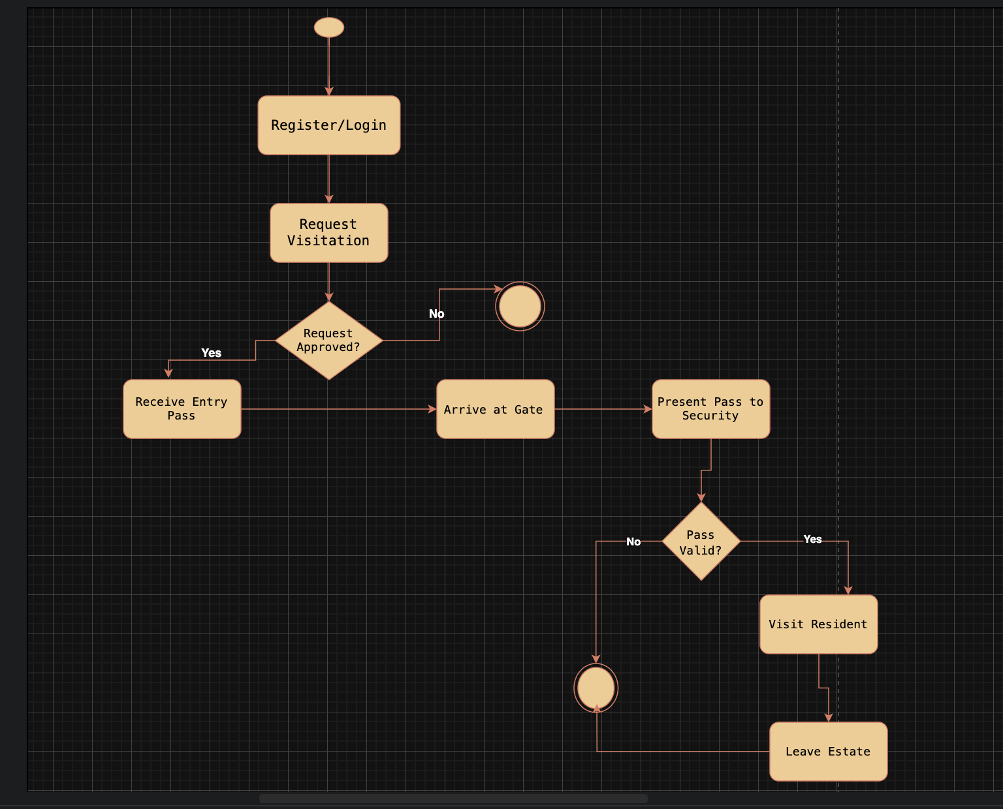

Figure 3.4 Visitation process

**Figure 3.4** presents a diagrammatic representation of the Resident’s process from their perspective.

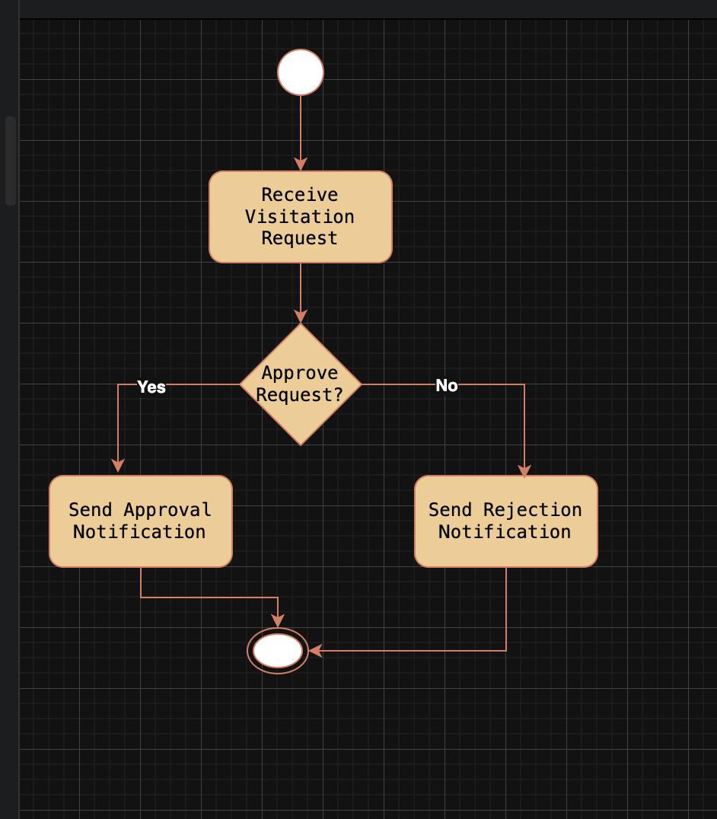

Figure 3.5 Resident’s process

**Figure 3.5** presents a diagrammatic representation of the Security process from their perspective.

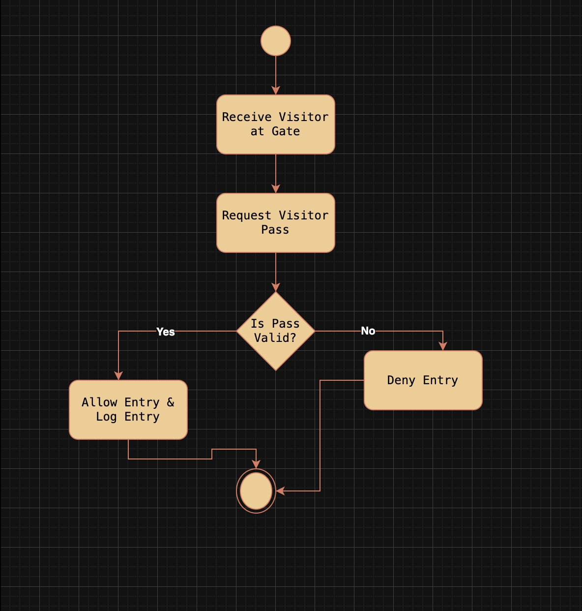

Figure 3.6 Security process

**Figure 3.6** presents a diagrammatic representation of the Admin process from their perspective.

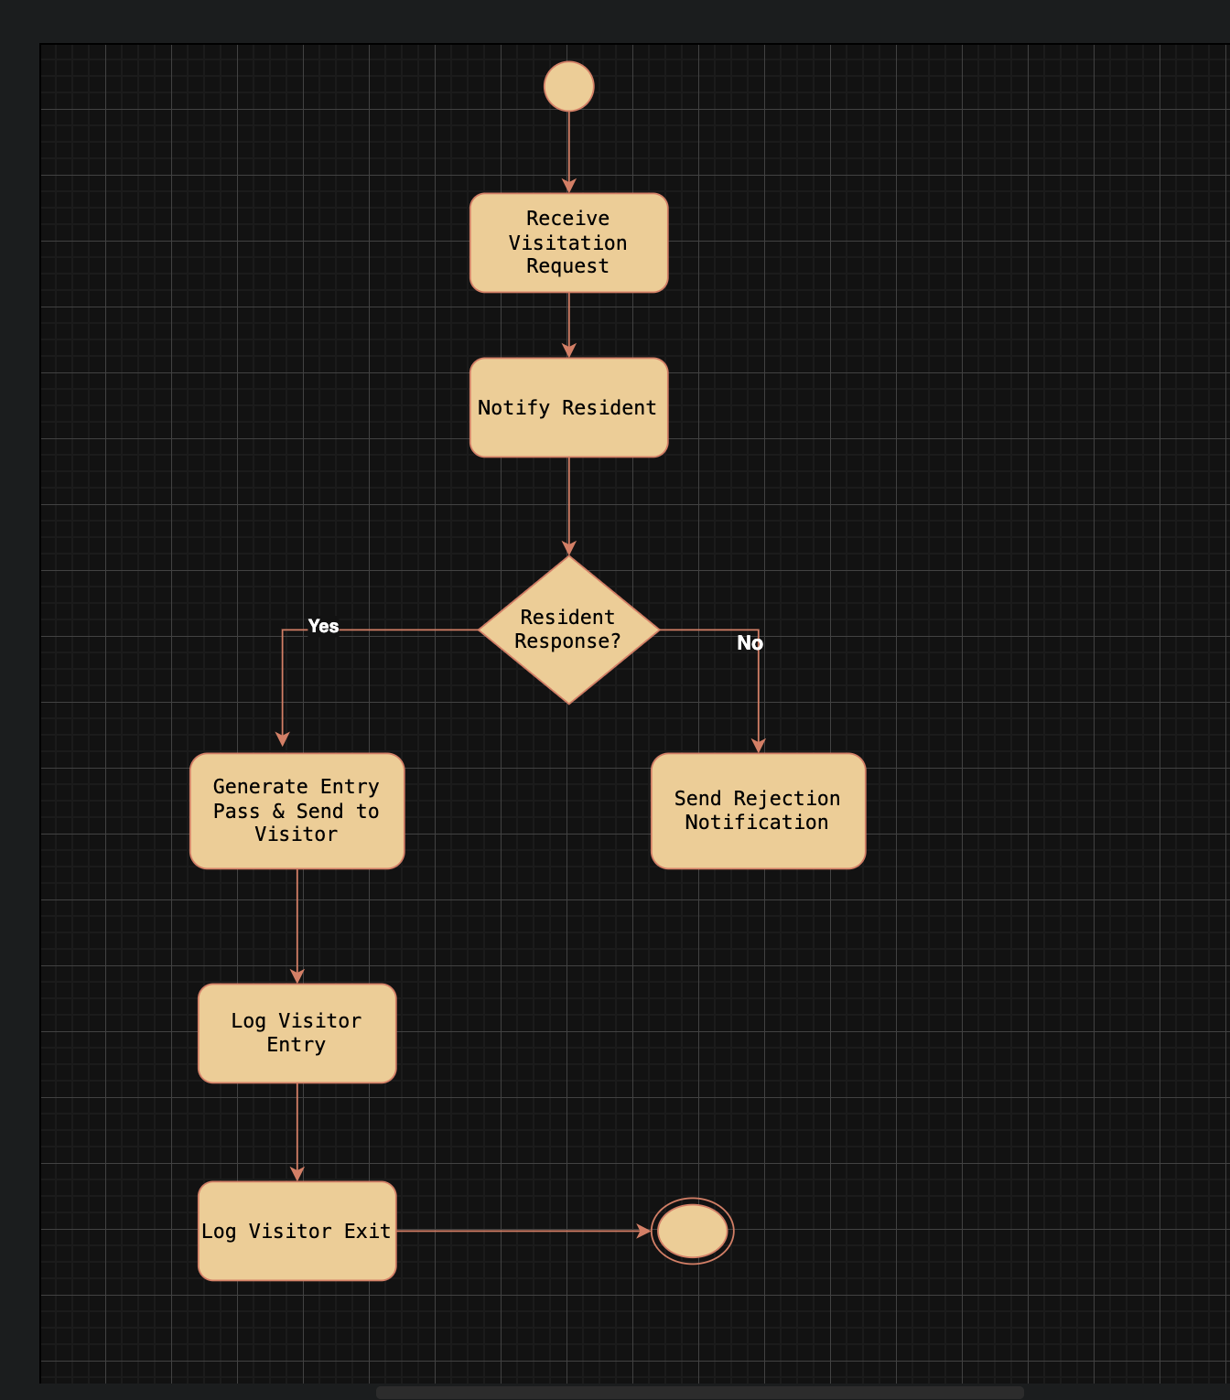

Figure 3.7 Admin process

### 3.8.5 Control Flow Diagram

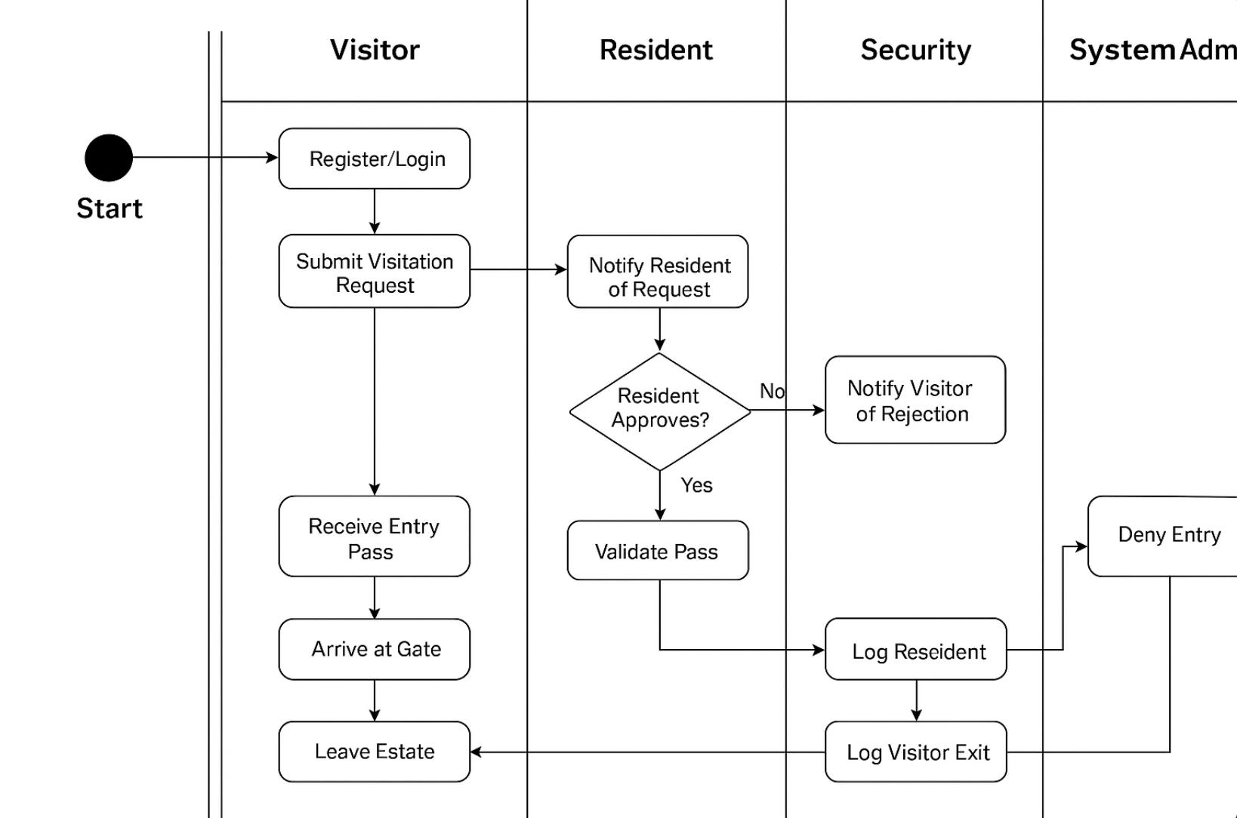

Figure 3.8 Control Flow Diagram

### 3.8.6 Entity Relationship Diagram (ERD)

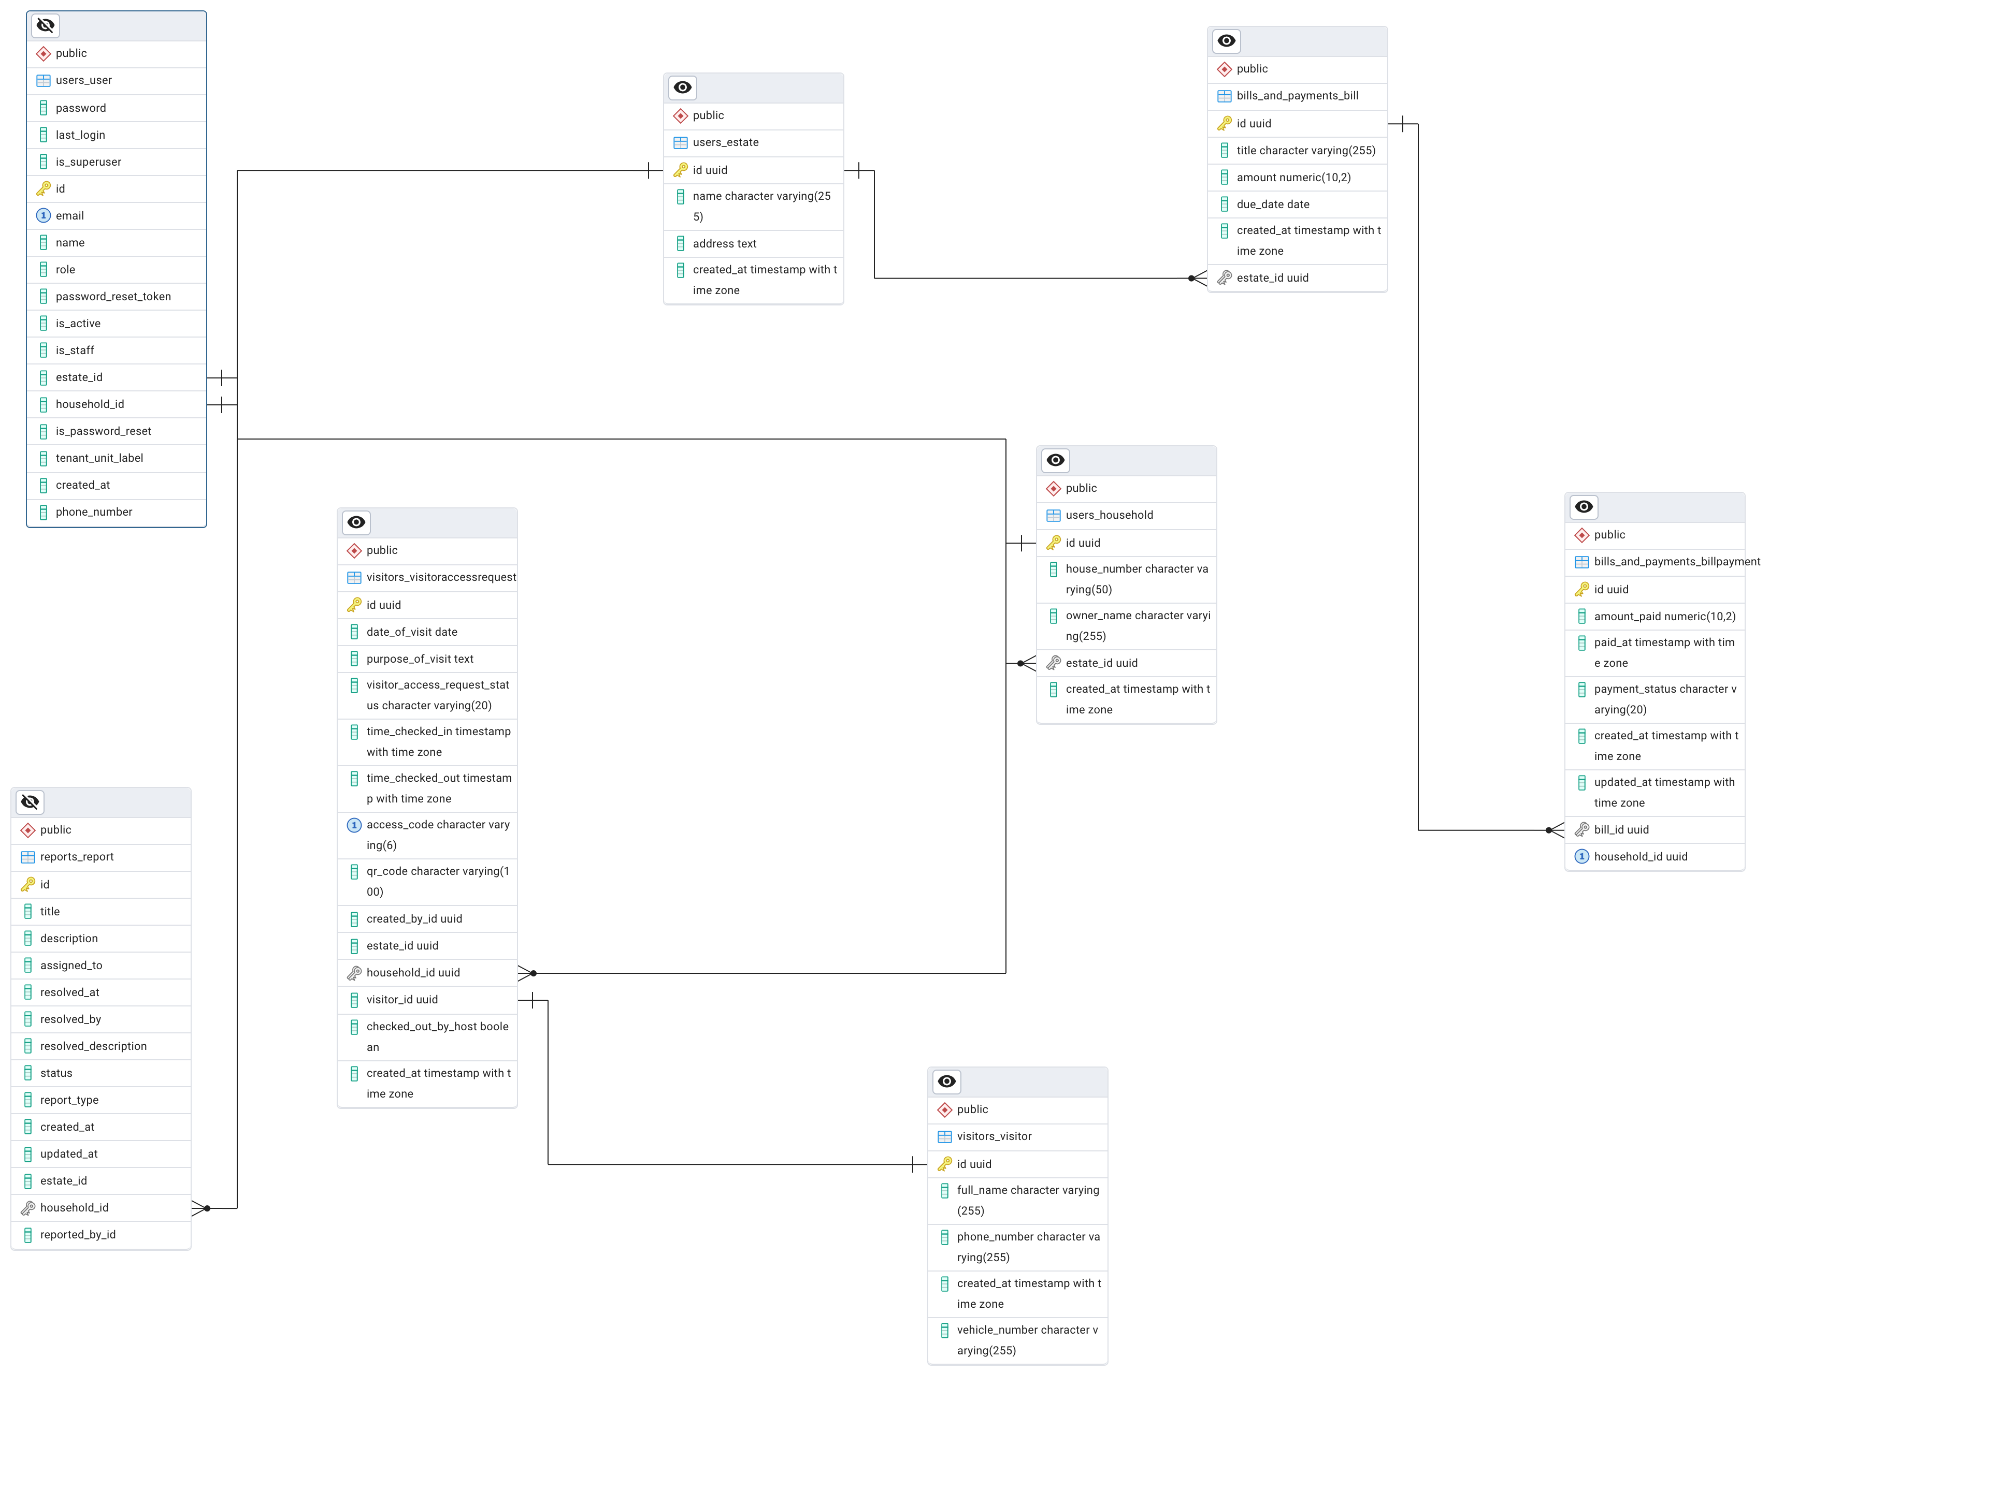

Figure 3.9 ERD

### 3.8.6 User Interface Design

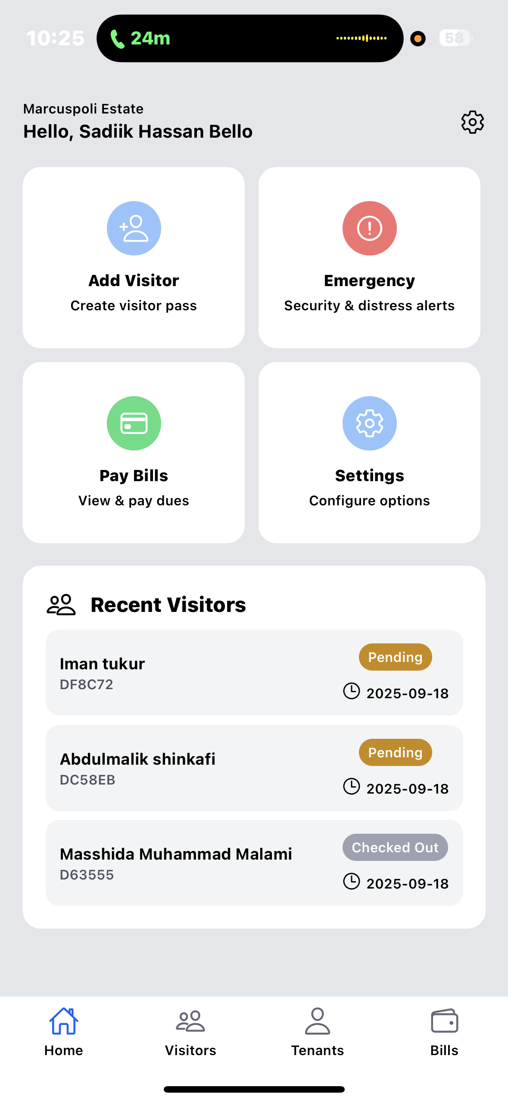

Figure 3.10 Resident App Dashboard

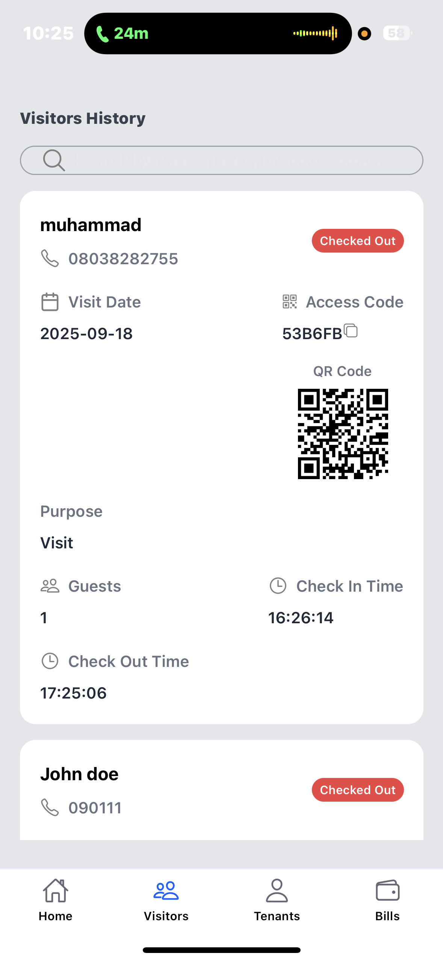

Figure 3.11 visitor log

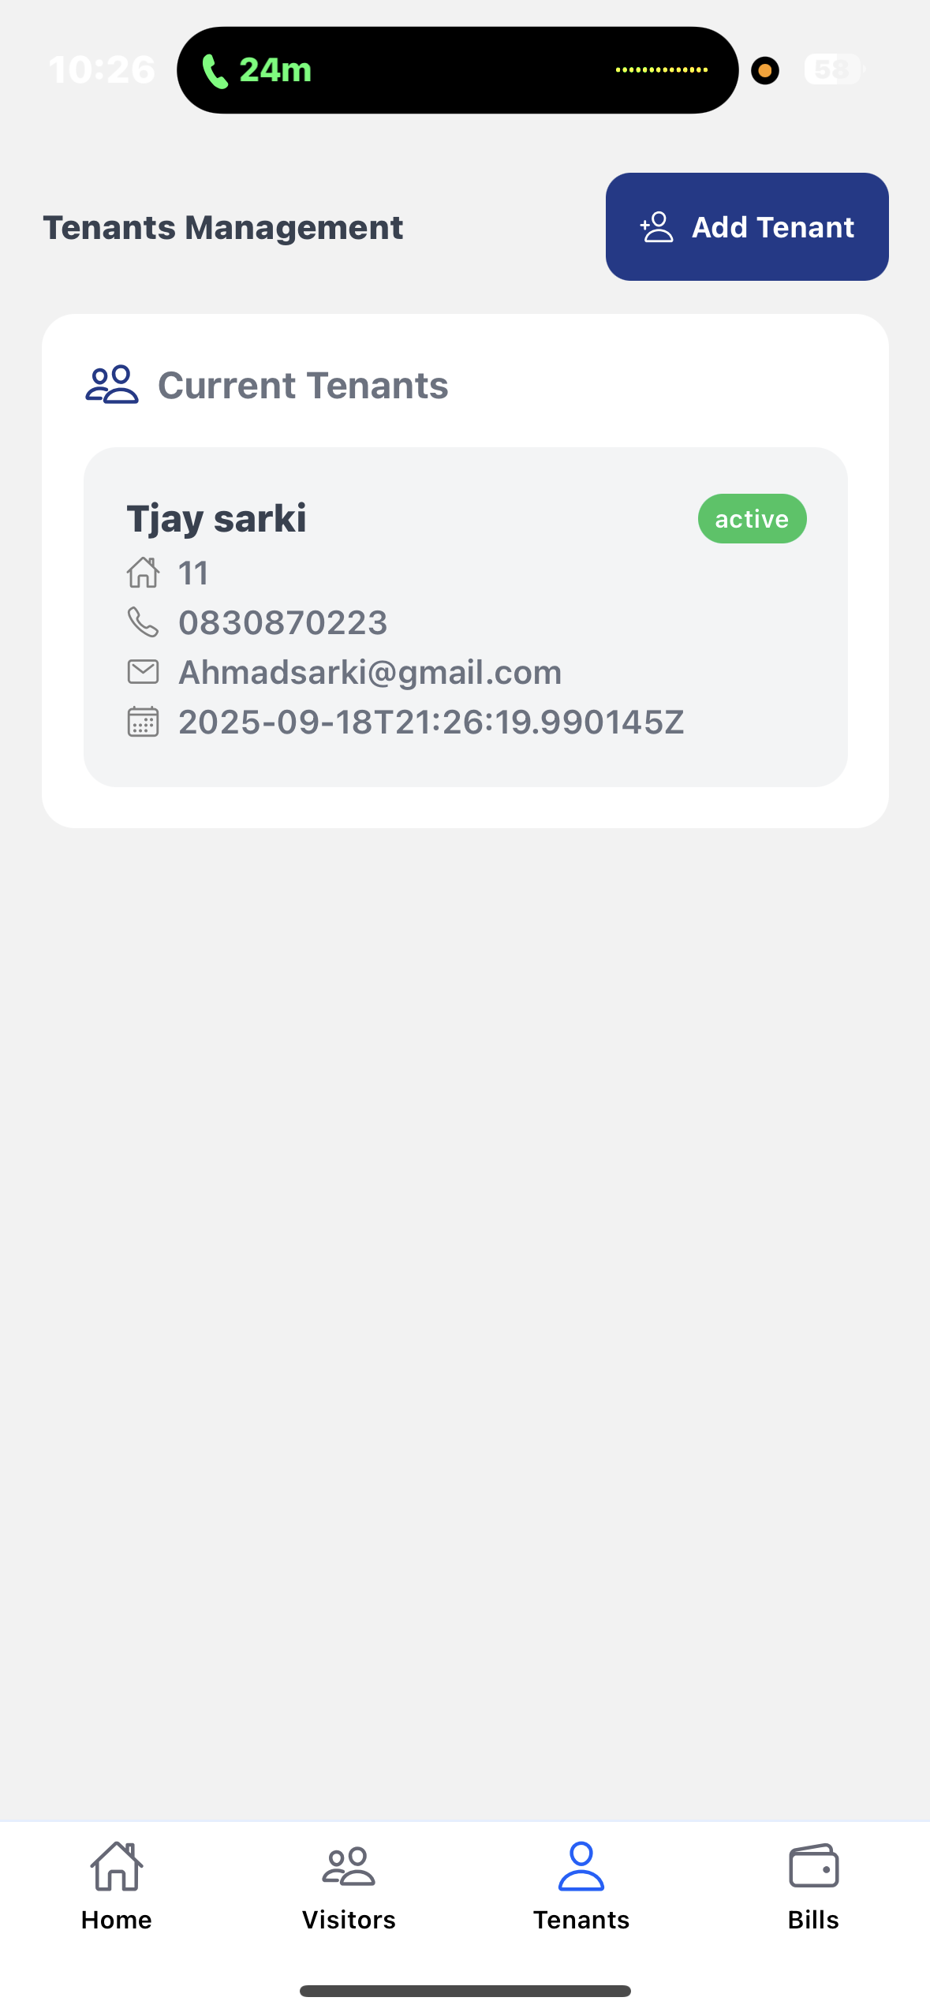

Figure 3.12 Tenants log

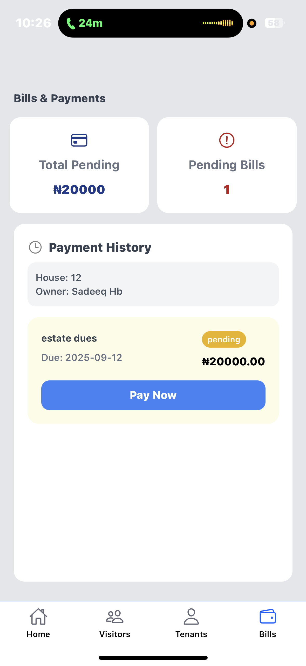

Figure 3.13 Bills Log

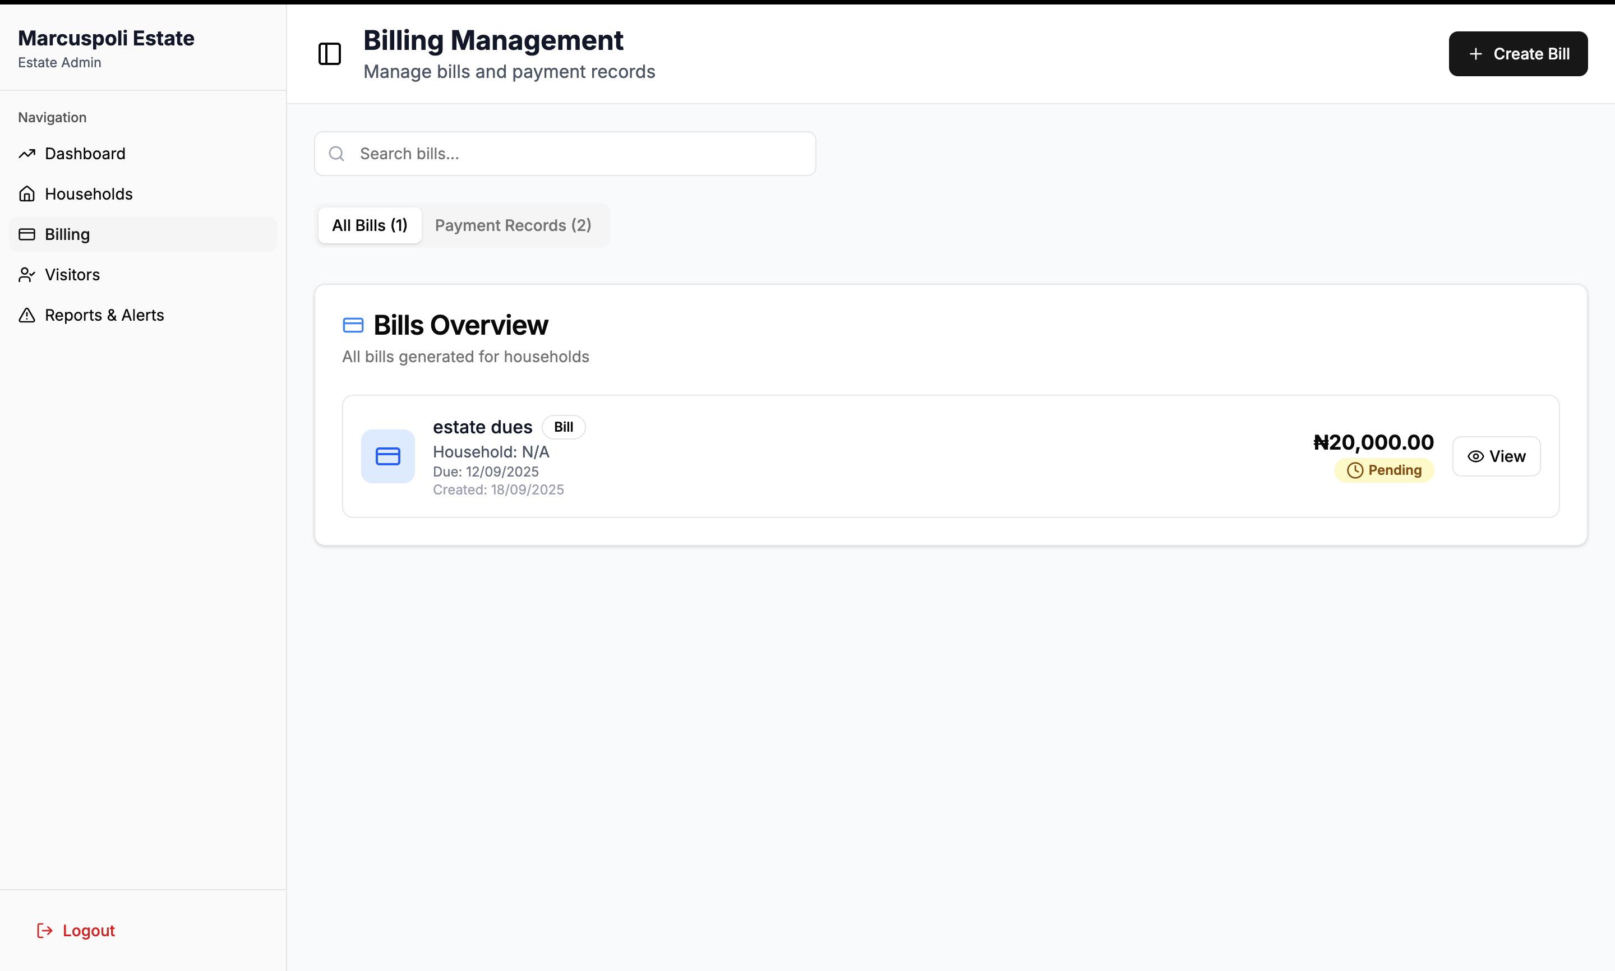

Figure 3.14 Admin bills log

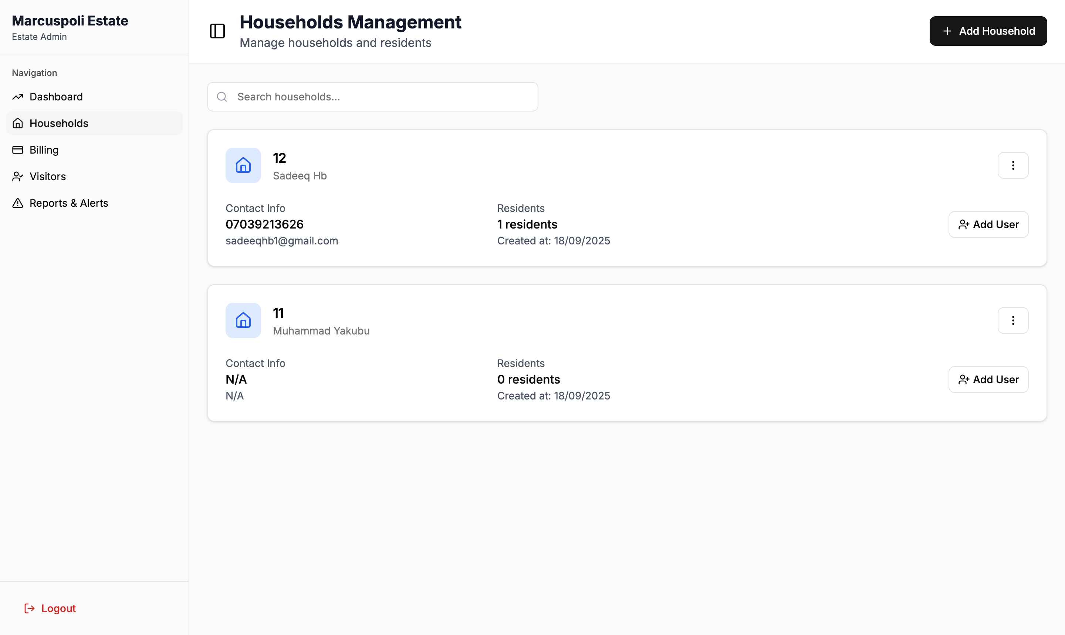

Figure 3.15 Admin household log

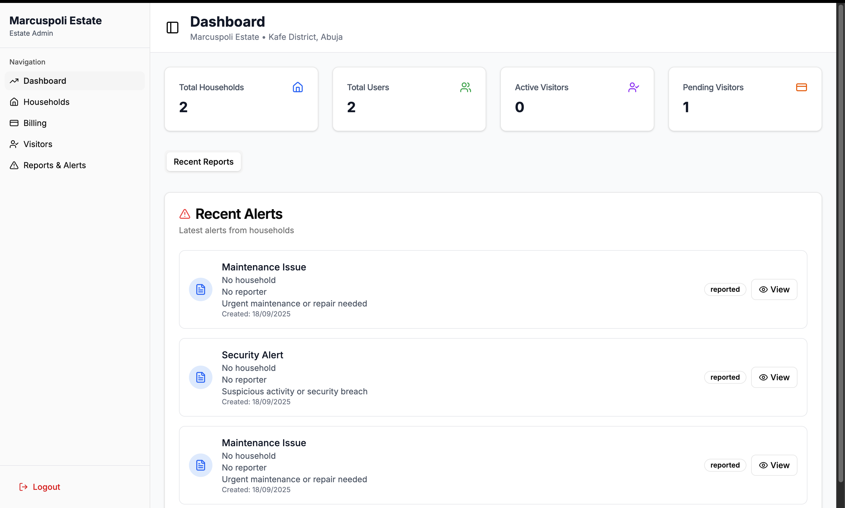

Figure 3.16 Admin alerts log

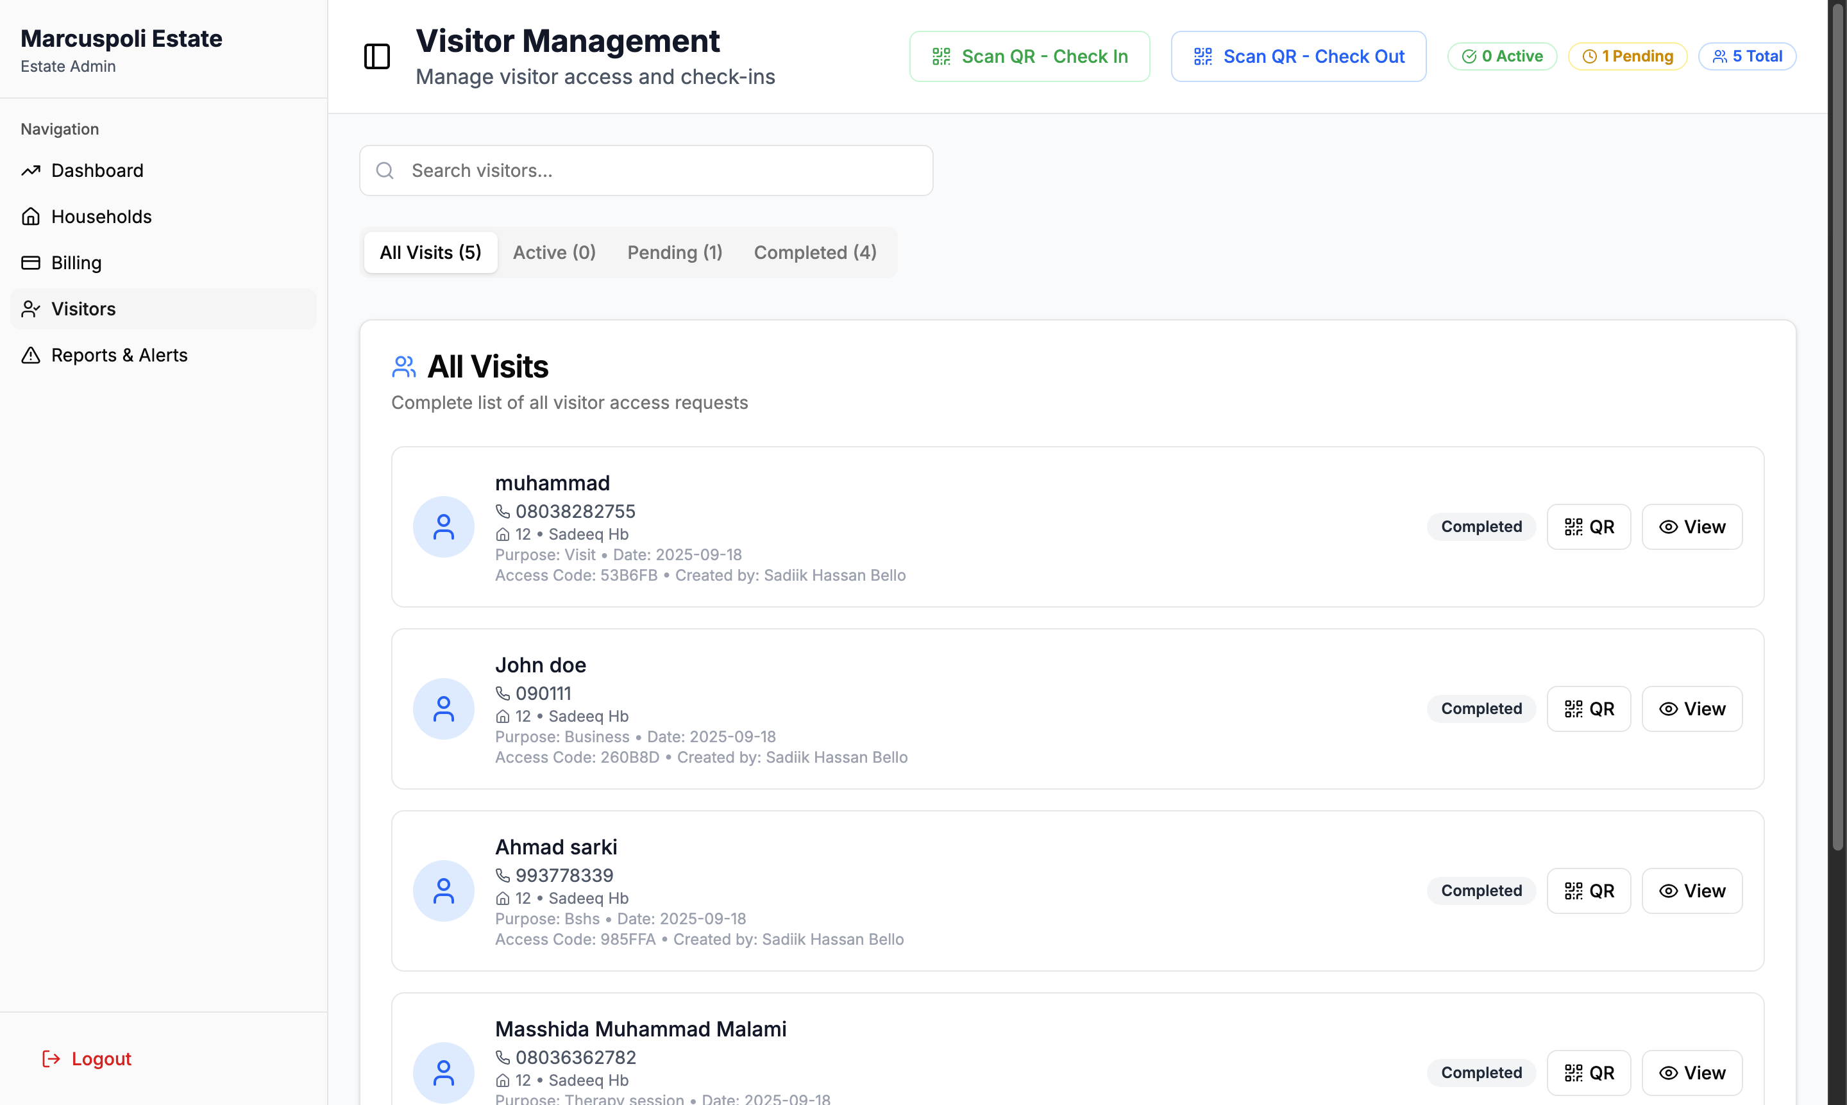

Figure 3.17 Admin Visitor's log

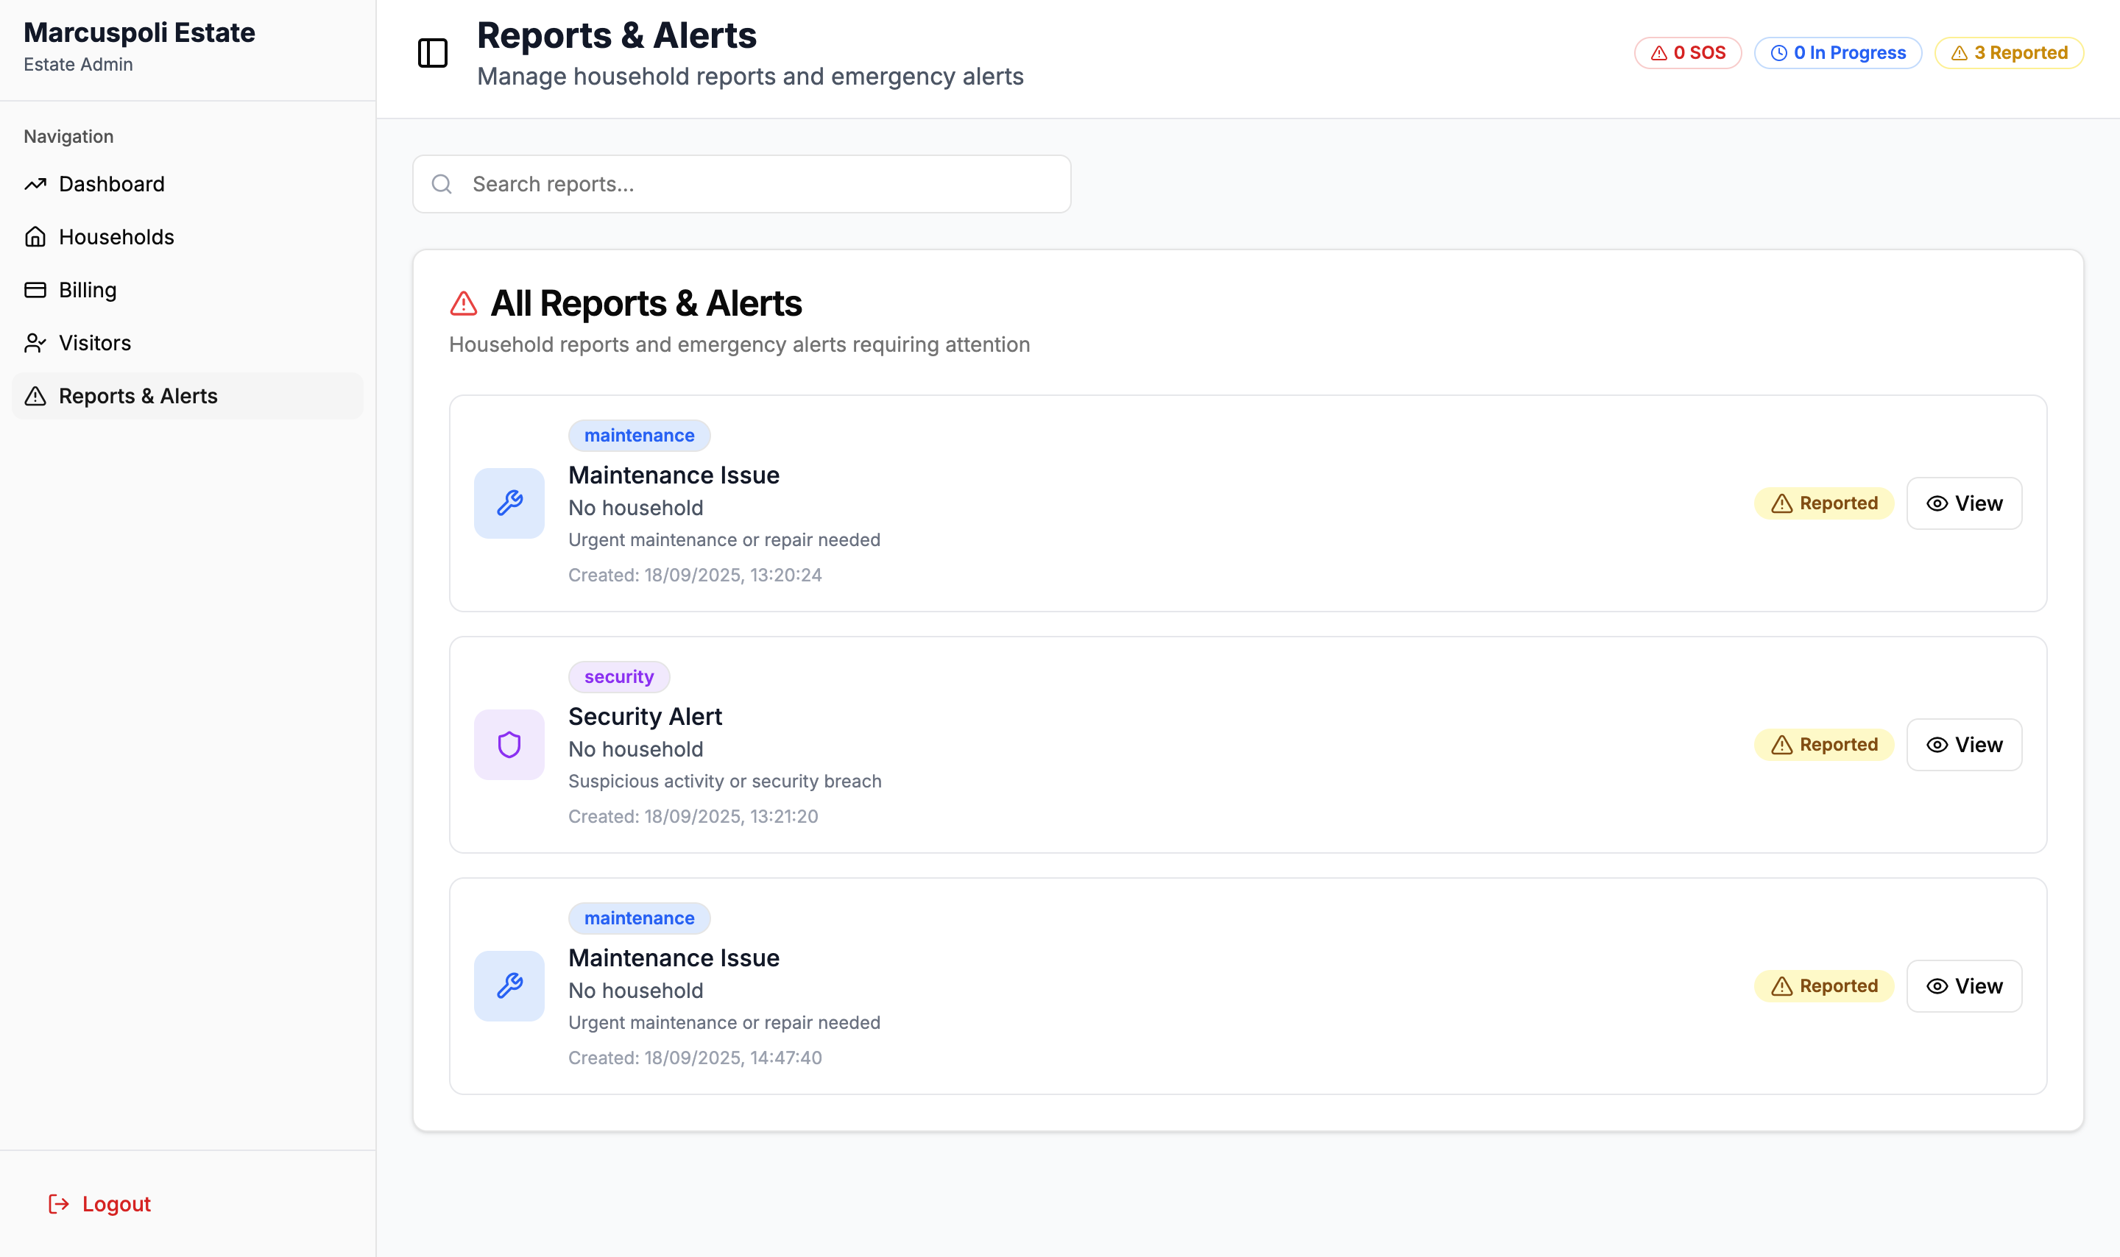

Figure 3.18 Admin report's log

3.9 Summary

We looked at the phases of requirement gathering, analysis, and design in this chapter. An outline of the chapter's contents was given in Section 3.1. We covered the proposed framework and approach in sections 3.2 and 3.2. After that, we talked about the tools and methods required to carry out the project. In this chapter, we described both functional and non-functional needs. Section 3.8 also included the Entity-Relationship Diagram (ERD), use case scenarios, user interface, and architecture of our system. Using Chapter 3, the next chapter will describe how we implement and test the many parts that make up our system.

# CHAPTER FOUR

# IMPLEMENTATION AND TESTING

4.1Overview  
The estate visitation system's deployment and testing are covered in this chapter. It describes the main elements that were created, the difficulties that came during the development process, and how those difficulties were overcome. Additionally, it explains the testing procedure, including the test cases, test plan, and test outcomes. A user manual for the system and an overview of the overall implementation and testing results round out the chapter.

## 4.2 Main Features

The estate visitation system's primary features include:  
**AUTHENTICATION:** The system is only accessible by users that the super admin has created. A certain position, such as visitor, resident, security, or administrator, is assigned to each user. In the system, the super admin creates their accounts and login information. After that, users can sign in with the credentials they were given. They can carry out the tasks permitted for their function after being authorized and taken to their role-specific dashboards.

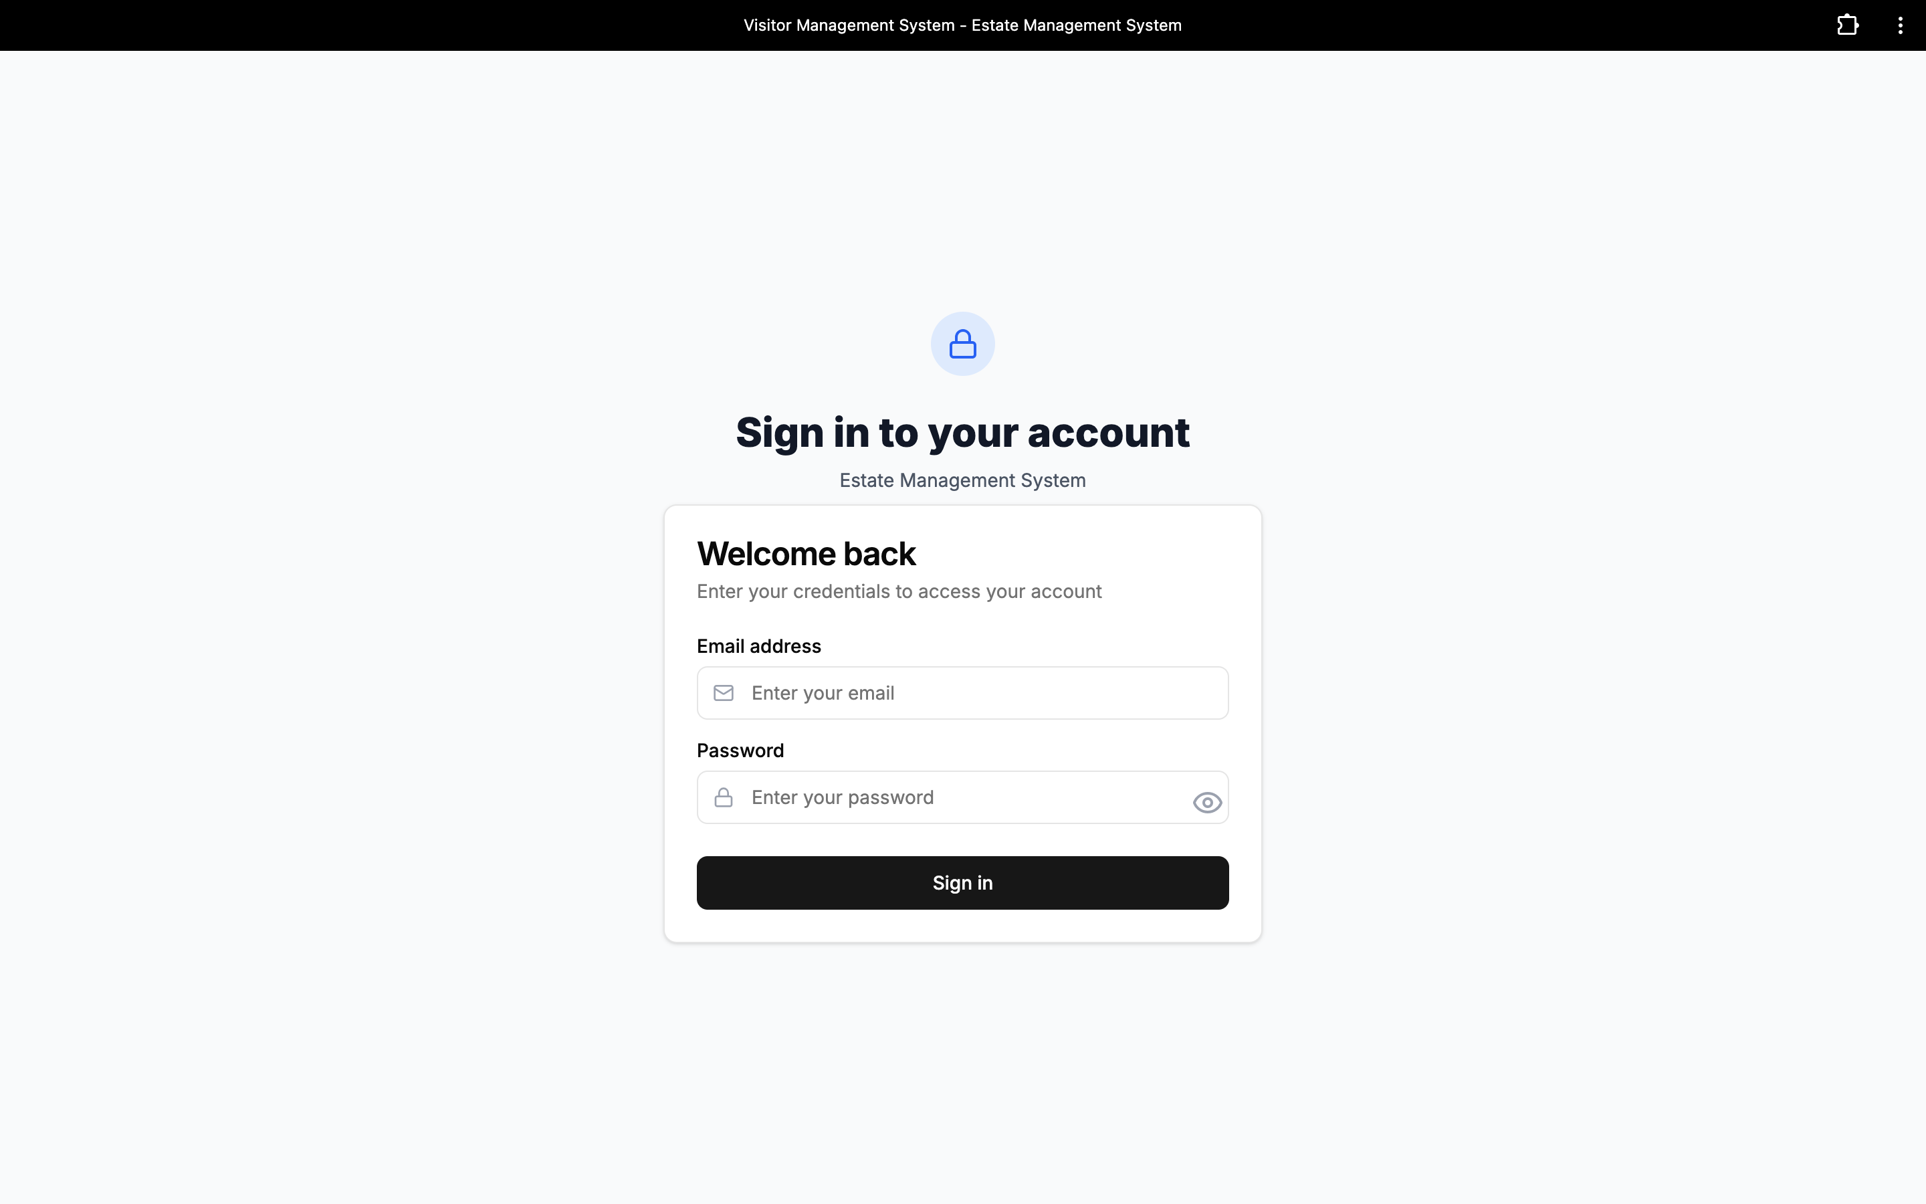

Figure 4.1 Admin Log in page

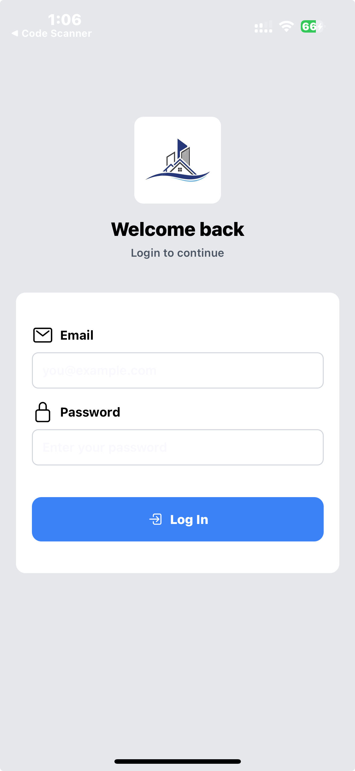

Figure 4.2 Resident Log in Page

**RESIDENT DASHBOARD:** The resident dashboard is the main user interface that residents use after logging into the system. It offers easy access to a number of estate-related resources and services. The following are key elements of the resident dashboard:

* Add Visitor
* Recent Visitors
* Emergency Alerts
* Handyman Services
* Bill Payment
* Settings
* Profile
* Logout
* Navigation tabs: Home, Visitors, Tenants, Bills



Figure 4.3 Residents Home Page

**ADMIN DASHBOARD:** The super admin's primary control panel is the admin dashboard. It offers complete system management, including user management, visitation tracking, and estate billing.

**Qualities**

* Create User Accounts
* Manage User Roles
* Modify or Eliminate Users
* User Password Reset
* Visitor Pass Scan
* Check-In and Check-Out Guests
* Generate and Maintain Bills
* Review the System Logs
* Control the Estate Configuration
* Page of the Admin Profile
* Log off



Figure 4. Admin Dashboard

## 4.3 Implementation Problems

One of the main issues faced during the estate visitation system's deployment was integrating the Tailwind CSS and Shadcn UI into the Next.js admin dashboard. The primary problems were an absence of a jsconfig.json file for Shadcn UI and improper tailwind.config.js file setting. Development was slowed down by these issues, which led to build faults.  
Connecting the React Native mobile application to the Django REST Framework backend presented another difficulty. CORS limitations and improper endpoint setups caused early problems with processing API requests, resulting in unsuccessful login and data-fetch attempts from the mobile application.

### 4.4 Resolving Issues with Implementation

I carefully examined how to configure Tailwind CSS and Shadcn UI in a Next.js project and adhered to the official manual in order to fix these problems. In order to resolve the build issues, I additionally modified the Tailwind setup and produced the necessary jsconfig.json file.  
I activated CORS in the Django REST Framework settings to address the backend connection problems, and I used Postman to verify that each endpoint was providing accurate replies. I changed the API base URLs and request headers on the React Native side to match the backend once the endpoints were operational. The communication issues between the server and the mobile app were fixed as a result.

## **4.5 Testing**

## To make sure the system was stable and functional, many tests were conducted. Using Django's built in testing tools, unit testing was performed on backend APIs to confirm data handling and logic. Each API endpoint was tested separately using Postman to verify the status codes and response accuracy. Key procedures, including login, visitation requests, approvals,   QR code scanning, and entry/exit recording, were thoroughly tested for the frontend using the React Native mobile app and Next.js admin dashboard. These tests improved the system's overall performance and dependability by assisting in the early detection and correction of problems.

### 4.5.1 Test Plans (For Unit Testing, Integration Testing, And System Testing)

Table 4.1 Test plans

|  |  |  |  |
| --- | --- | --- | --- |
| **Test Plan ID** | **Test Type** | **Test Objectives** | **Test Tools** |
| TP-01 | Unit Testing | Verify that every single module or endpoint (like login, visitation request, approval, and pass generation works well by itself. | Django Test Framework, Postman |
| TP-02 | Integration Testing | Verify that the admin dashboard (Next.js), backend (Django REST Framework), and mobile app (React Native) all function together and communicate data correctly. | Postman, Chrome Dev Tools, Reactive Native Debugger. |
| TP-03 | System Testing | Evaluate the estate visitation system's overall functionality and performance to make sure all requirements are satisfied. | Postman, Chrome Dev Tools, Mobile Device Emulator. |

### 4.5.2 Test Suite (For Unit Testing, Integration Testing And System Testing)

Table 4.2 Test Suite

|  |  |  |  |  |
| --- | --- | --- | --- | --- |
| Test Suite ID | Test Type | Test Description | Test Steps | Expected Outcome |
| TS-01 | Unit Testing | Test User Log in | 1- Navigate to the Log in Page.  2- Enter both valid and invalid credentials.  3- submit. | Successful log in for valid credentials and unsuccessful log in for invalid credentials. |
| TS-02 | Unit Testing | Test visitation request | 1- log in as visitor.  2- Navigate to the visitation request page.  3- Fill out the form with valid and invalid data.  4- Submit. | Request is created with valid data and error is returned for invalid data. |
| TS-03 | Unit Testing | Test residents approval/decline | 1- Log in as resident.  2- View pending request.  3-approve or decline a request. | Approved requests moved to approved. visit and declined requests are removed. |
| TS-04 | Integration Testing. | Test Visitor pass generation | 1- Visitor submit a valid request.  2- Resident approves the request | System generate a QR code with correct visitor or visitor details. |
| TS-05 | Integration Testing | Test Security Validation | 1- Log in as security.  2- Scan visitor’s QR code. | Valid pass grants access, Invalid or expired pass denies entry. |
| TS-06 | Integration Testing | Test residents bill payment | 1- Log in as resident  2- navigate to bill section.  3-Attempt to pay outstanding bill. | Payment is processed successfully, System updates bill status to success. |
| TS-07 | System Testing | Test visitor history logs | 1- Log in as visitor.  2- Navigate to visit history page. | A list of past visit will be displayed with correct details. |
| TS-08 | System Testing | Test entry and exiting logging | 1- Visitor arrives at the gate.  2- Security scan the pass and grants access.  3- Visitor exit estate. | Entry and. Exit are logged correctly with timestamps. |
| TS-09 | System Testing | Test admin user management | 1- Log in as admin.  2- create a new user with role(resident, Tenants).  3.Edit and delete user. | Users are successfully created, updated or removed when needed. |

### 4.5.3 Test Traceability Matrix (For Unit Testing, Integration Testing And System Testing)

Table 4.3 Test Traceability Matrix

|  |  |  |
| --- | --- | --- |
| Test Case ID | Test Description | Status |
| TC-01 | Create resident or security account by Super Admin | Pass |
| TC-02 | Reject duplicate account with already, Registered details | Pass |
| TC-03 | Log in with valid details (Admin, Security and Residents) | Pass |
| TC-04 | Reject log in with invalid credentials | Pass |
| TC-05 | Request visitation by visitor and QR generation | Pass |
| TC-06 | Approve or reject visitation by resident | Pass |
| TC-07 | Scan visitor QR code at the gate for check in | Pass |
| TC-08 | Scan visitor QR code at the gate for check out | Pass |
| TC-09 | Deny entry when QR code is invalid or denied | Pass |
| TC-10 | Admin create, view and manage bills for residents | Pass |
| TC-11 | Admin view and manage residents visitors logs and history | Pass |
| TC-12 | Prevent unauthorized access to pages/routes | Pass |

### 4.5.4 Test Report Summary (For Unit Testing, Integration Testing And System Testing)

Most test cases performed perfectly during the testing procedure. While efforts to log in using invalid credentials were rightly rejected, access was successfully given using correct credentials. For both check in and check out, visitor QR/barcode passes could be scanned at the estate gate after being correctly generated upon request. As anticipated, attempts to use expired or invalid passes were not allowed entry.

The smooth syncing of visitor requests, resident approvals, and security scans was ensured by integration tests, which also verified that the connection between the mobile application (React Native) and the backend services (Django REST Framework) worked as intended.  
All essential functional and non functional requirements were confirmed to be satisfied by system testing. The Admin correctly established and maintained billing records, protected routes were unreachable without authentication, and estate visitation logs were appropriately updated upon the arrival and departure of guests.

### 4.5.5 Error Reports and Corrections

Table 4.4 Error Reports and Corrections

|  |  |  |  |
| --- | --- | --- | --- |
| Error ID | Description | Correction | Status |
| ER-01 | Missing ”.as_view()” method in users/urls.py file while using class based views | Added the .as_view() method to every class based on view referenced in urls.py. | Fixed |
| ER-02 | Visitor QR code not generating due to misconfigured API route | Corrected the API endpoint path and updated the front end cell | Fixed |
| ER-03 | Unauthorized users accessing protected routes through direct URL input | Added authentication middleware and rout guards | Fixed |
| ER-04 | Resident bill creation failed due to missing database migration | Ran Django migration and updated the related models | Fixed |

## 

## 4.6 SUMMARY

For managing resident services and estate access, the Estate Visitation System has effectively offered a safe and easy platform. Visitors can only request visits, obtain QR code passes, and enter the estate gate after obtaining the necessary approval and validation, according to the system. In addition to these advantages, residents can use their personal dashboard to access other services including bill payment choices and handyman service requests.  
The Super Admin uses the admin dashboard to manage user accounts, create bills and keep an eye on estate operations, while security staff may quickly check guests in and out using the QR code scanner. Additionally, the system strictly requires authentication, guaranteeing that sensitive data and protected routes are only accessible by authorised individuals.

# CHAPTER FIVE: DISCUSSION, CONCLUSION, AND RECOMMENDATIONS

5.1 Overview

In this chapter, the main insights learnt from the Estate Visitation System's deployment are presented. It offers a thorough examination of the difficulties experienced during the development process, the limitations that were encountered, and the process in which the project's goals were met. In order to improve the system's functionality, usability, and general efficacy, the chapter highlights possible future development areas and provides helpful suggestions.

## 5.2 Objective Assessment

As stated in Chapter One, the primary goals of this project were to improve overall estate administration, improve resident access through extra services, guarantee proper access control, and offer a safe and effective platform for managing estate visits. These goals have been effectively met, according to the outcomes of the implementation and testing phases.  
Visitors can only request a visit and obtain entry through the system after receiving the appropriate approval and having their QR code validated at the estate gate. While residents take advantage of features like bill payment and handyman service requests, security staff may quickly check in and out guests. In order to maintain efficient estate operations, the  Admin efficiently maintains user accounts, visiting logs, and financial records.

## 5.3 Limitations and Challenges

The process of creating this application enabled me to learn about topics in which I had little to no prior exposure. CORS (Cross-Origin Resource Sharing), the use of PUT and PATCH request methods, and frontend optimisation strategies like the Local Storage API were among the things I learnt about. My technical knowledge and general development abilities were enhanced by these.  
However, the project also came with a number of obstacles and restrictions that had an impact on some of the anticipated characteristics. Among these are:

* unable to obtain user GPS coordinates for more accurate tracking of visitor whereabouts.
* The resident-handyman service request module's picture upload feature is still underdeveloped.
* Residents and security personnel can view real-time updates on "Online" or "Offline" status indications.
* Instantaneous email alerts for visitation updates, bill production, and approvals.
* For improved login security, two-factor authentication (2FA) is not used.  
  automated check-in and check-out for guests without the need to manually scan barcodes or QR codes.

5.5 Future Work

Although the system works and accomplishes its main goals, there are still certain things that could be improved in the future to make it more useful and efficient. These consist of:

1. Support for photo uploads in incident reporting and handyman service requests has been added.
2. Allowing residents, security, and administrators to see real time Online or Offline status indicators.
3. Creating a module for automated reminders for payments and invoices.
4. Increasing the use of biometric verification for check-in and check-out (such as fingerprint or face recognition).
5. Introducing an announcement feature that would enable the Administrator to instantly notify every resident of announcements or notifications that affect the entire estate (such as maintenance plans, security alerts, or community events).
   1. Recommendations

The following suggestions are offered in accordance with the experience gathered while this project was being developed:

1. To better secure user accounts, implement more stringent security methods like Two-Factor Authentication (2FA).
2. To enhance system testing and validation, make sure that actual user data is properly collected and managed.
3. Train system administrators and security personnel how to operate the system efficiently, paying particular attention to the QR/barcode scanning function.
4. Update and maintain the system frequently to add features, improve performance, and address bugs.
5. Use automated alerts (email or SMS) to facilitate real-time communication between residents, guests, and security.
   1. Summary  
      The Estate Visitation System was thoroughly reviewed in this chapter. The evaluation in section 5.2 verified that the system achieved its main goals of boosting resident convenience, streamlining estate visits, and boosting security. The constraints and difficulties faced during development, including integration problems and the lack of real-world datasets, were covered in Section 5.3. Suggestions for enhancing system security, usability, and general efficacy were described in Section 5.4. Future work opportunities were examined in Section 5.5, which included automated billing, biometric authentication, GPS-based visitor tracking, and an announcement feature for estate-wide communication.

## References

Adebayo, M., & Yusuf, H. (2024). Data analytics and PropTech adoption in Africa. *African Journal of Information Systems, 11*(3), 102–118.

Adetayo, K., & Okonkwo, L. (2022). Affordable QR-code visitor management systems in Nigerian estates. *Journal of African ICT, 14*(2), 77–89.

Chen, W., & Ibrahim, T. (2025). Social media and privacy in estate security management. *Journal of Security and Technology in Africa, 9*(1), 55–70.

Chowdhury, P., & Patel, S. (2023). Cybersecurity issues in visitor management platforms: A European perspective. *International Journal of Cybersecurity, 8*(2), 45–61.

Chukwu, J., & Hassan, M. (2023). Evaluating global property management platforms in Africa. *PropertyTech Review, 7*(1), 33–47.

Daramola, B., & Usman, R. (2024). User experiences with visitor management systems in Lagos estates. *Nigerian Journal of ICT, 10*(4), 210–225.

Davis, F. D. (1989). Perceived usefulness, perceived ease of use, and user acceptance of information technology. *MIS Quarterly, 13*(3), 319–340.

Disrupt Africa. (2022, December 8). Nigerian PropTech startup VENCO secures $670k pre-seed funding round. *Disrupt Africa.* <https://disruptafrica.com/2022/12/08/nigerian-prop-tech-startup-venco-secures-670k-pre-seed-funding-round/>

Disrupt Africa. (2023, February 1). How Nigeria’s VENCO is simplifying estate management for managers. *Disrupt Africa.* <https://disruptafrica.com/2023/02/01/how-nigerias-venco-is-simplifying-estate-management-for-managers/>

El-Baz, M., & Rashed, A. (2023). A systematic review of PropTech innovations in real estate management. *Journal of Real Estate Studies, 22*(1), 14–29.

Gate Africa. (2025). *Gate Africa visitor management platform.* [https://gateafrica.com](https://gateafrica.com/)

Gopinath, R., & Chen, L. (2021). QR-code authentication for visitor management during COVID-19. *International Journal of Smart Technology, 6*(4), 65–82.

Guardian. (2024, March 14). Gate Africa unveils app for estate management. *The Guardian Nigeria.*<https://guardian.ng/features/gate-africa-unveils-app-for-estate-management/>

Helixbeat Research. (2022). *PropTech innovations in global real estate.* Helixbeat Research Reports. [https://helixbeat.com](https://helixbeat.com/)

Ibrahim, K., & Musa, S. (2023). Barriers to PropTech adoption in Nigeria. *Nigerian Journal of Information Technology, 9*(2), 140–155.

Mensah, P., & Boateng, K. (2024). Mobile-first PropTech systems in West Africa: Opportunities and challenges. *African Journal of Digital Innovation, 5*(2), 88–104.

Nwachukwu, E., & Bello, T. (2021). Integrated estate management systems in Nigeria: A case study of VENCO. *Nigerian Journal of Urban Development, 8*(2), 70–86.

Okafor, D., & Bello, S. (2025). Comparing RFID and QR-code access systems in Nigerian gated communities. *Journal of African PropTech, 2*(1), 1–15.

Olawale, J., & Adeyemi, A. (2020). Gate Africa and the future of visitor access control in Nigeria. *Journal of Housing and Security, 15*(3), 200–213.

Olaniyi, A., & Adnan, M. (2023). Artificial intelligence in estate visitor verification: Potentials and challenges. *International Journal of AI in Africa, 4*(1), 23–41.

Rees. (2019). *About Rees Tech.* [https://www.reestech.com](https://www.reestech.com/)

Rogers, E. M. (2003). *Diffusion of innovations* (5th ed.). Free Press.

TechStartups. (2022, December 5). Nigerian PropTech startup VENCO lands $670k pre-seed funding. *TechStartups.*<https://techstartups.com/2022/12/05/nigerian-proptech-startup-venco-lands-670k-pre-seed-funding-simplify-rent-collection-payments-residential-commercial-properties-africa/>

VENCO Technologies. (2024). *PropTech platform overview.* [https://venco.ng](https://venco.ng/)

Wei, H., & Sun, L. (2024). YOLOv8-based license plate recognition systems for estate access management. *International Journal of Computer Vision, 12*(3), 112–129.

Yardi. (2018). *Yardi Breeze launch announcement.* Yardi Systems. [https://www.yardi.com](https://www.yardi.com/)

Yardi Breeze. (2025). *Yardi Breeze property management platform.* [https://yardibreeze.com](https://yardibreeze.com/)

Zhang, Y., & Liu, Q. (2020). Blockchain-enabled visitor management in smart buildings. *Journal of Information Security, 19*(1), 55–70.

Wei, H., & Sun, L. (2024). YOLOv8-based license plate recognition systems for estate access management. International Journal of Computer Vision, 12(3), 112-129.

Yardi Breeze. (2025). Yardi Breeze property management platform. Retrieved from https://yardibreeze.com

Zhang, Y., & Liu, Q. (2020). Blockchain-enabled visitor management in smart buildings. Journal of Information Security, 19(1), 55-70.

# APPENDIX A – Questionnaires

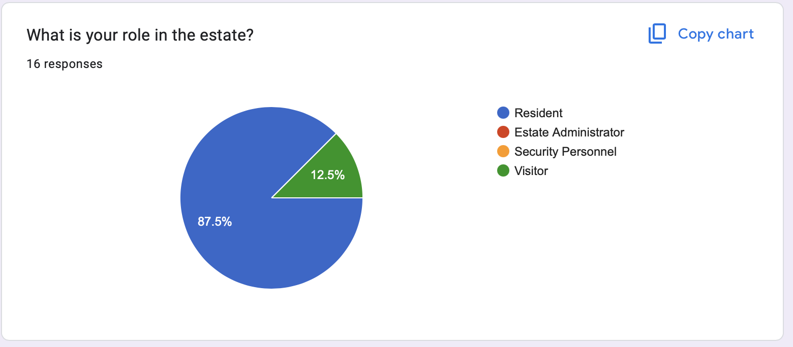

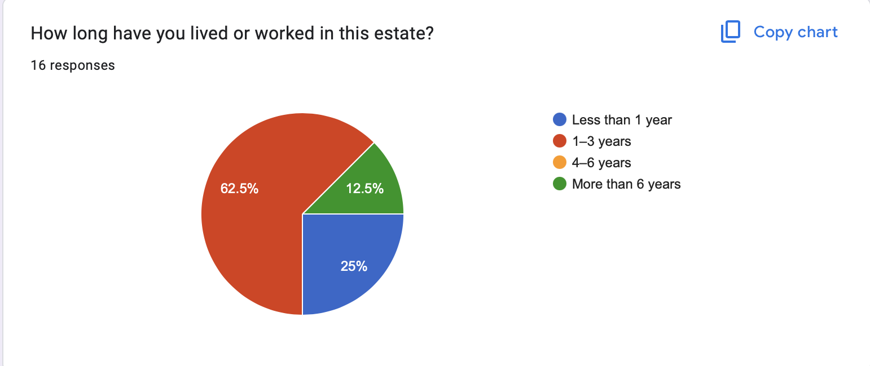

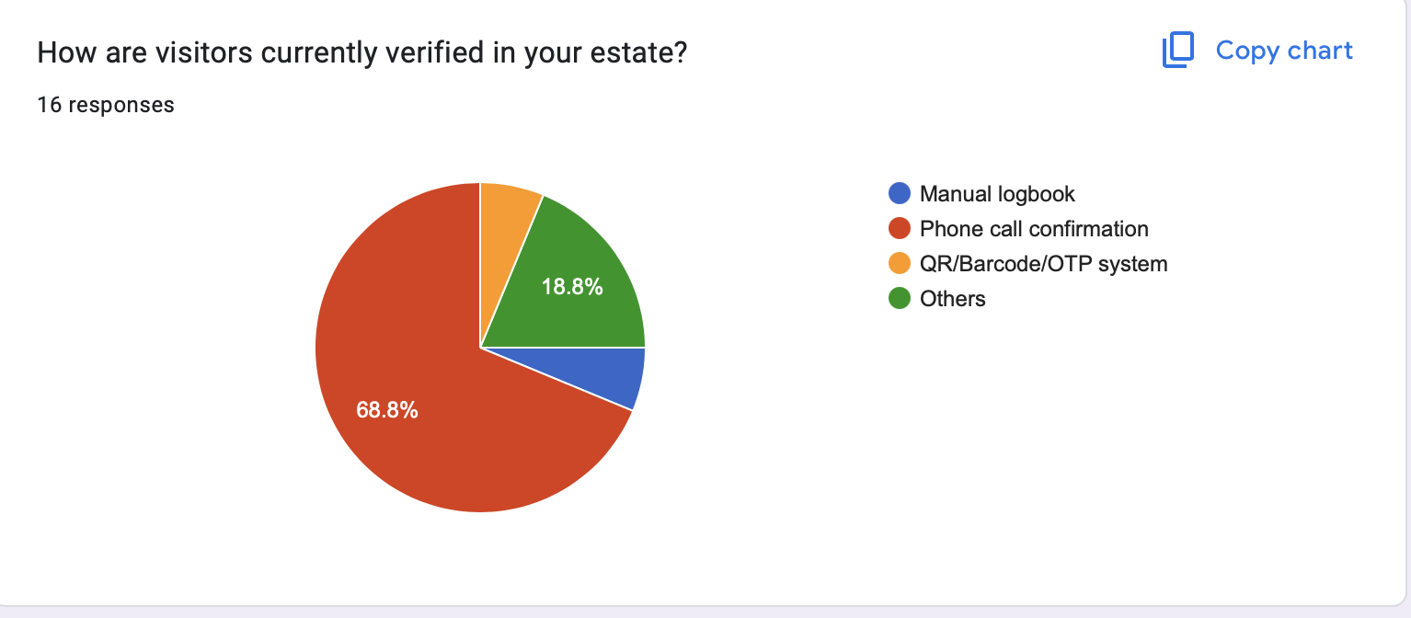

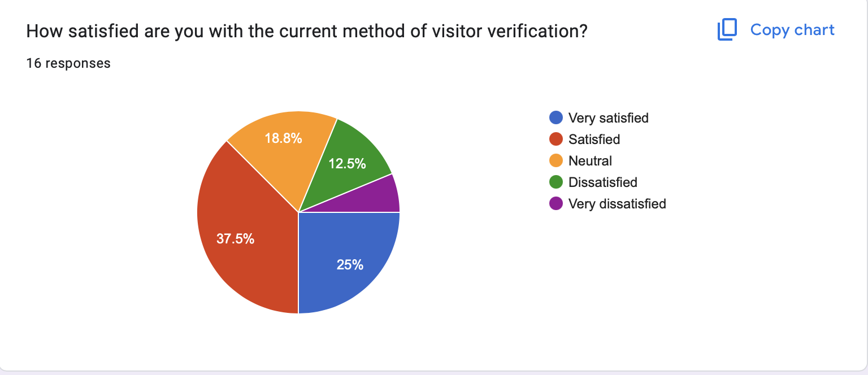

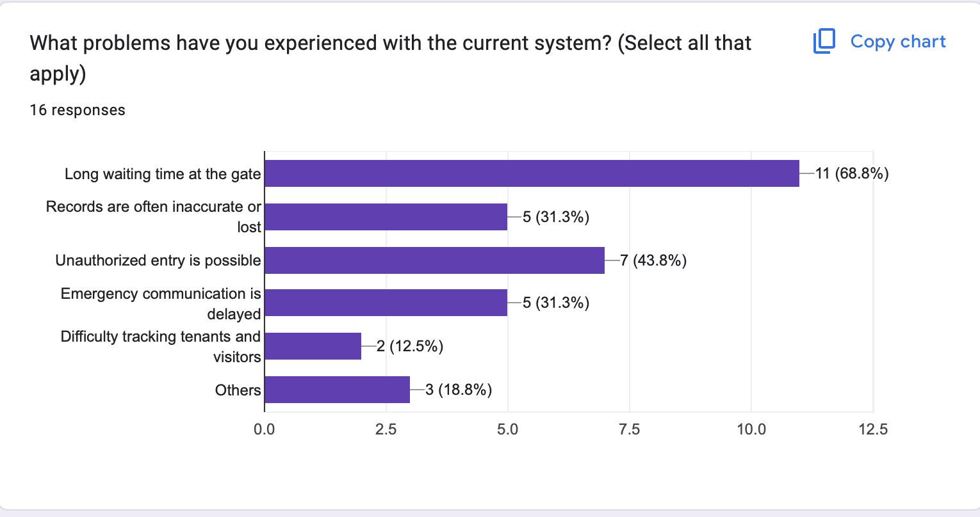

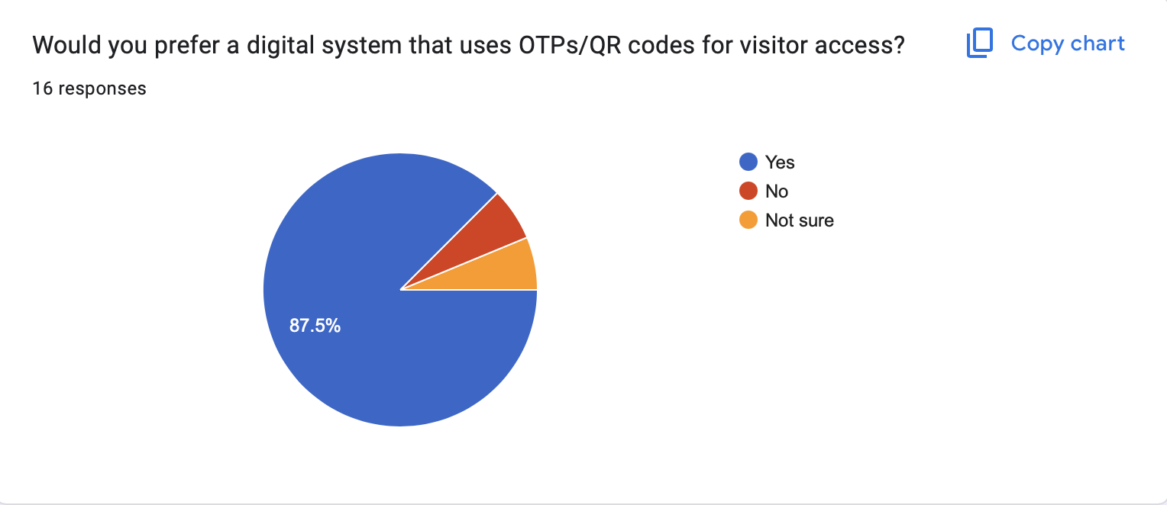

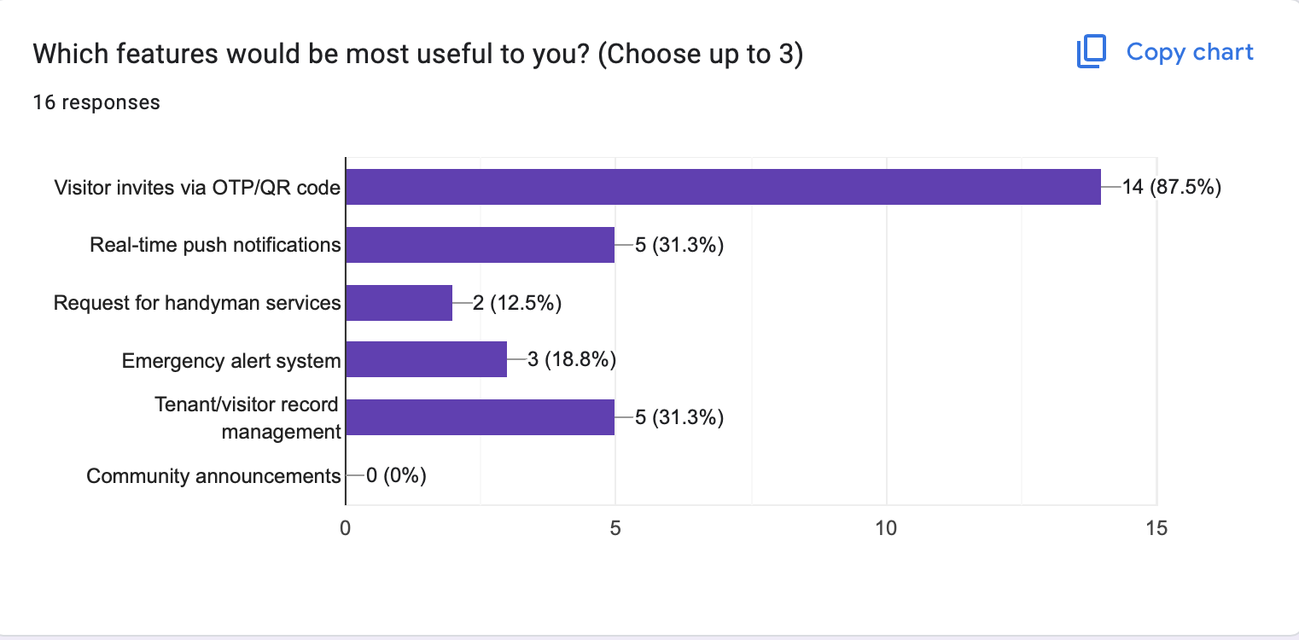

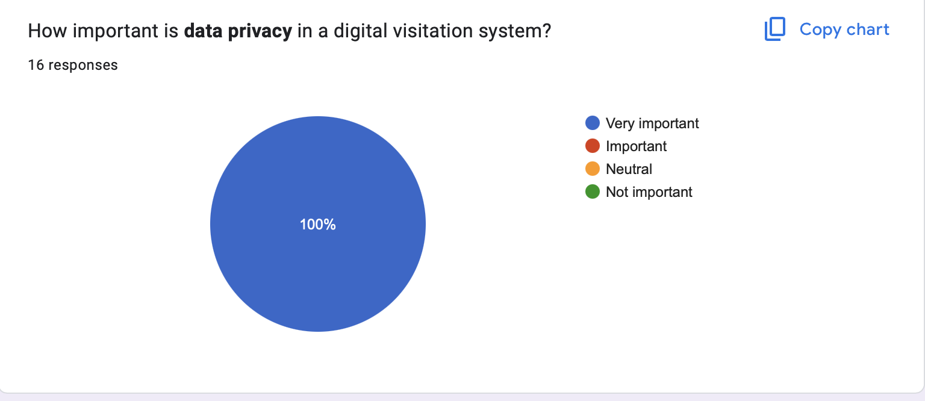

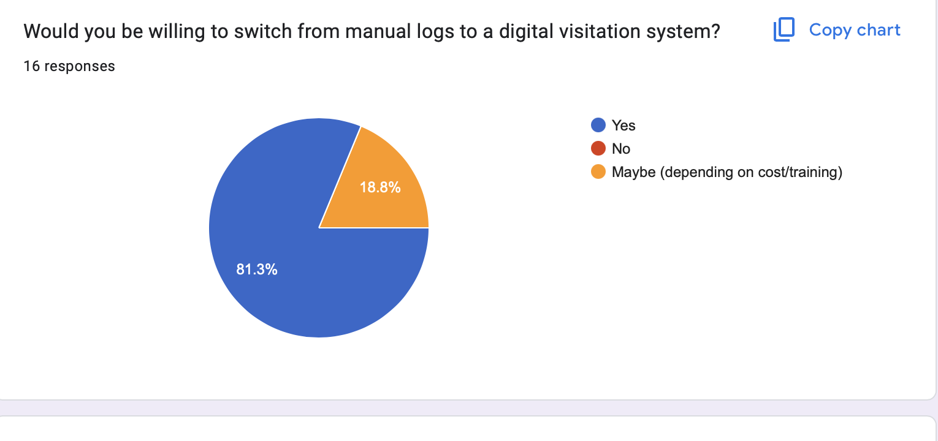

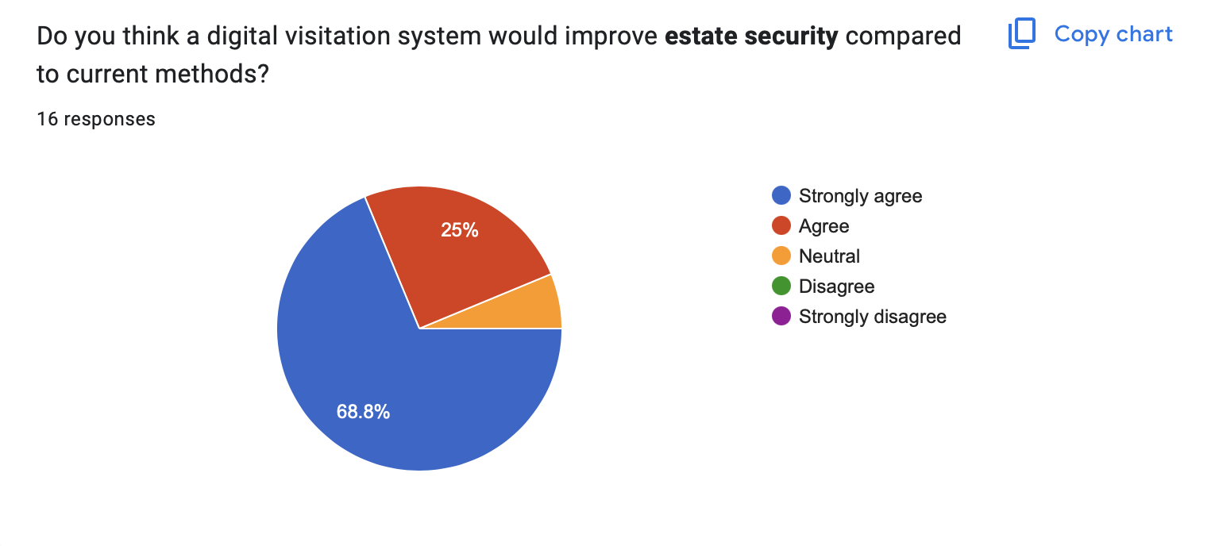

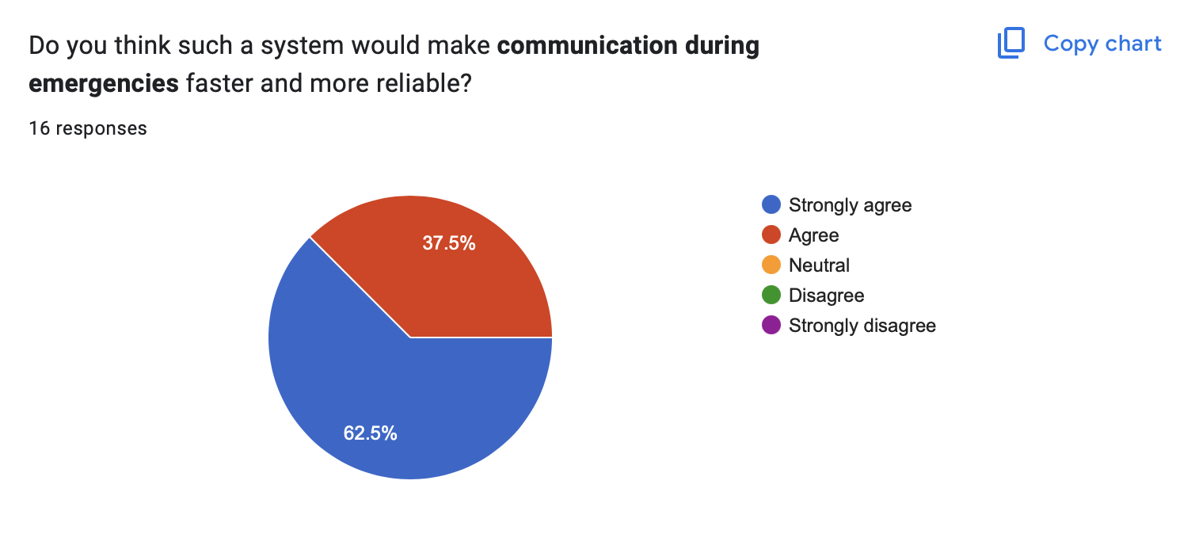

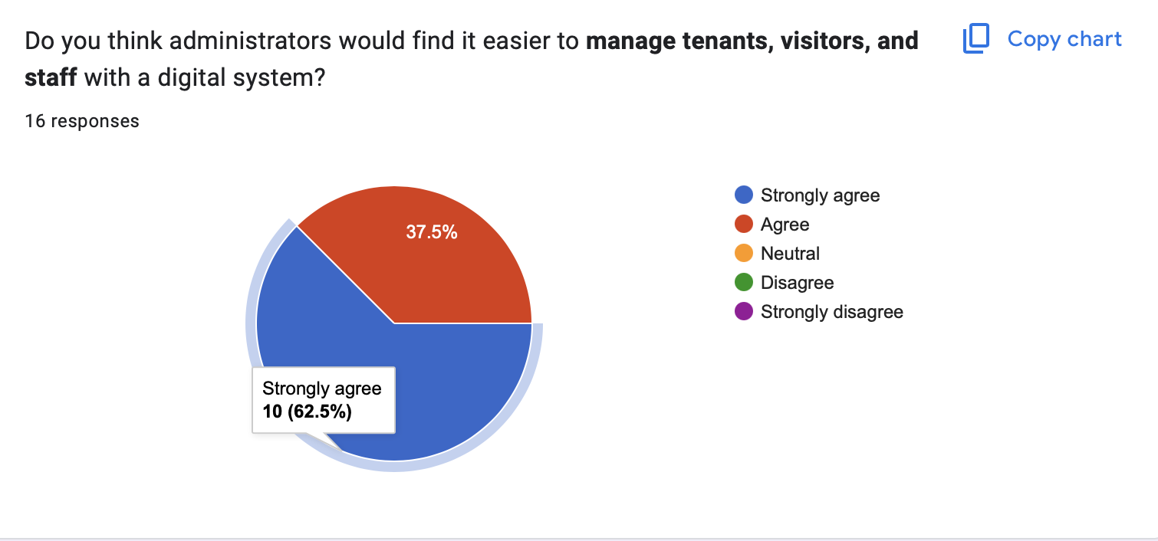

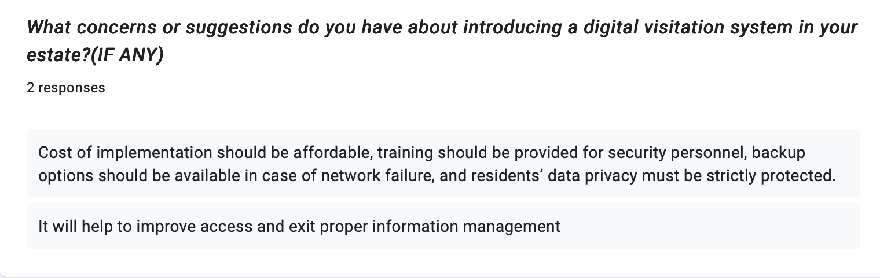

# APPENDIX B – Use Guide

**Step 1: Lunch the Application**

* Make sure your device is connected to the internet before opening the App.
* Once connected to the internet, open the App on your mobile device. Or desktop.

**Step 2: Account sign in**

* Once registered by the Admin, enter log in credentials and log in.

**Step 3: Dashboard Overview**

* Once logged in, you will be taken to the dashboard.
* On the dashboard you can see the visitors stats such as number of visitors, recent check ins, pending maintenance requests and emergency Alerts.
* You can navigate the dashboard to move between sections.

**Step 4: Registering a visitor**

* Go to visitor tab.
* Click on Add new visitor.
* Fill in the visitor’s details.
* An invite will be generated for visitor including the QR code.

**Step 5: Visitor verification(Security)**

* Security personnel should open the verification area on their security app on their device.
* At the gate and scan the visitor’s QR code.
* The System will automatically grant access if the QR code is legit.
* And then mark the visitor as checked in .
* And then mark the visitor as checked out once checked out.

**STEP 6: Maintenance Requests**

* Navigate to maintenance tab.
* Click create request for maintenance.
* And it will be popped to the Admin Dashboard.

**STEP 7: Emergency Alerts**

* Tap on the emergency button from the dashboard to quickly notify security or estate Admin.
* Security or estate Admin can see and respond to it immediately.

**STEP 7: Settings**

* Click settings from the dashboard to make any profile changes etc.

**STEP 8: Logging out**

* To log out click on the profile icon by the top right corner.
* Select log out.to exit the system.